NFCA RECRUITING CAMP EVENT MANAGER’S MANUAL
2014

NFCA Mission Statement
To assist in the professional development of fastpitch softball coaches through educational services and cooperative efforts with other professional organizations, while stimulating the growth and promotion of the sport, and competition in the highest traditions of athletics.



© 2010 National Fastpitch Coaches Association. All rights reserved

TABLE OF CONTENTS
ADMINISTRATIVE INFORMATION

PAGE
Timelines for Summer and Fall Camps 4 & 5

Equipment 6
Facility 6
Insurance 6
Quick Facts 6
Exhibitors 6

NFCA Contract 6
Camp Personnel 7

Recruiting Camp Brochure 7
Camp Applications 7
Banners 8
NFCA Logo 8

Marketing Responsibilities 8

T-shirts 9

Camp Numbers 9
NCAA Guide for the College-Bound Student-Athlete 10
Wrist Bands 10

Student-Athlete and Parent Information Sessions 10

Processing Campers 11
Student-Athlete Information Booklets 11

Coaches Book 11

Recruiting Coach Registration 12
Athlete Registration 12

Evaluation Forms 12
Camp Times and Speeds 12
Certified Athletic Trainer 12

General Camp Format 13

Student-Athlete Testing Times 14

TABLE OF CONTENTS

SESSION AND FIELD INFORMATION

PAGE
On-Site Check-In 16

Timeline for Session One 17

Staffing Overview 18

Staff Assignment Sheet 19

Rotations for Session One 20

Outfield Staff Notes 21

Outfield Drills 22

Outfield Diagram 23 & 24

Catcher Staff Notes 25

Catcher Drills 26

Catcher Diagram 27

Timeline for Session Two 28

Pitcher Staff Notes 29

Pitcher Drills 30

Pitcher Diagram 31

Timeline for Session Three 32

Infielder Staff Notes 33

Infielder Drills 34

Infielder Diagram 35

Offensive Field Notes 36

Offensive Drills 37

Timed Sprints 38

Overhand Throw 39

Exhibits Page 40

Exhibits List 41

TIMELINE FOR SUMMER CAMPS

September 15 -Confirm exact camp date, tournament date, and appropriate contact person with the NFCA
-Make sure NFCA membership dues are paid.

October 15 -Return signed contract to the NFCA.

February 28 February 28 -NFCA will UPS camp brochures to the event manager.
-Event managers should mail Brochures to all participants or to participant travel ball coaches.

May 1 -Order numbers, wrist bands, shirts, banners etc.
-Finalize camp staff, trainer and speakers.
-Obtain camp insurance listing NFCA as an additional
insured for at least $1 million per occurrence.
-Obtain or secure necessary camp equipment.

One Month Prior -Mail acceptance letter, student-athlete information booklet and Payment/Insurance form.
-Mail a copy of the insurance certificate to NFCA.

Two Weeks Prior Call student-athletes who have not paid to see if they still plan on attending.

One Week Prior -Assign each athlete a number.
-Prepare coaches books.

After Camp After Camp -Mail thank-you notes to coaches who attended the camp.

Two Weeks After -Send NFCA the following:
- Endorsement Fee - $10 per paid participant
- Copy of college coaches camp and tourney book
- List of colleges represented by attending coaches (electronically)
- College coach CAMP sign-in sheets
- Student-Athlete testing results
- All Evaluation Forms (coach and athlete)
- Camp T-shirt
- Copy of your camp’s student-athlete Payment/Insurance Form
- Copy of your camp’s student-athlete acceptance letter
- Copy of your camp’s Student-Athlete Information Booklet
- A packet provided to student-athletes at registration
- Total number of athletes in your camp __________
- Total number of college coaches present at CAMP ____________
- Total number of colleges represent by college coaches at your CAMP ________

TIMELINE FOR FALL CAMPS

September 15 -Confirm next year’s exact camp date, tournament date, camp
schedule, camp fee, and appropriate contact person with the NFCA.
-Make sure NFCA membership dues are paid.

November 15 -Return signed contract to the NFCA.

June May -NFCA will UPS camp brochures to the event manager.

Mid May -Mail Camp Brochures to all tournament participants.

June 1 -Order numbers,wrist bands, T-shirts, banners etc.
-Finalize camp staff, trainer and speakers.
-Obtain camp insurance listing NFCA as an additional insured
for at least $1 million per occurrence.
-Obtain or secure necessary camp equipment.

One Month Prior Mail acceptance letter, student-athlete information booklet and medical/registration form.
-Mail a copy of the insurance certificate

Two Weeks Prior -Call student-athletes who have not paid to see if they still plan on attending.

One Week Prior -Assign each athlete a number.
-Prepare coaches book.

After Camp After Camp -Mail thank you notes to coaches who attended the camp.

Two Weeks After -Send NFCA the following:
- Endorsement Fee - $10 per paid participant
- Copy of college coaches camp and tourney book
- List of colleges represented by attending coaches (electronically)
- College coach CAMP sign-in sheets
- Student-Athlete testing results
- All Evaluation Forms (coach and athlete)
- Camp T-shirt
- Copy of your camp’s student-athlete Payment/Insurance Form
- Copy of your camp’s student-athlete acceptance letter
- Copy of your camp’s Student-Athlete Information Booklet
- A packet provided to student-athletes at registration
- Total number of athletes in your camp __________
- Total number of college coaches present at CAMP ____________
Total number of colleges represent by college coaches at your CAMP _______

Equipment

The Event Manager is responsible for providing the necessary equipment for his/her camp. The NFCA will provide a listing of all equipment utilized at NFCA administered camps. (Exhibit #1) Event Managers may utilize this list as a guideline for necessary camp equipment.

Facility

There must be a minimum of three (more efficient with four) dirt fields available for use [*A Minimum of 4 for a camp run in the shorter time frame i.e. 3pm- 7pm]. A "wheel-like" facility is recommended so that recruiting coaches can observe easily and efficiently. It is important that bathrooms, telephones, and concessions are available and accessible.

Insurance

The event manager is responsible for camp insurance. A copy of the certificate of insurance, with the NFCA listed as an additional insured for $1 million liability, must be given to the NFCA prior to the camp date. Any specific questions regarding NFCA required insurance can be directed to Janice Briggs, Summit America Insurance, at 800/955-1991.

Quick Facts

The endorsed camp director should develop a “Quick Facts” sheet listing all camp pertinent information. Each college coach downloads a camp specific Quick Facts sheet when he/she registers on the NFCA web site. (Exhibit #2)

Exhibitors

NFCA Corporate Teammates may have camp day access at no charge. They may exhibit and sell from inside the complex fences and on the concourse. Other vendors may be sold exhibit space, but must locate outside the complex on camp day. NFCA Corporate Teammates for 2014: Louisville Slugger, Diamond, Schutt, and Mizuno (This list may be updated and made available as others join as NFCA corporate teammates). Other companies may have signage inside the park as long as they are not competing companies of the above-mentioned sponsors.

Contract

The NFCA will draft a contract that will be agreed upon between the NFCA and the local event director. A general camp information form will be included with the contract. This form should be completed and returned with the contract. (Exhibit #4)

The NFCA endorsement fee is $10 per camp participant with a minimum of $1200 to be remitted to the NFCA. The NFCA camp registration fee for endorsed camps is $100 per participant for one session and $75 for a second session.

Please add a flat fee of $800 if a NFCA support staff person is desired to attend your camp on camp day. This person would staff the parent information session and would be available to assist with the college coach registration and any other last minute on-site problems or questions.

Personnel

1 Event Manager
1 Site Director
15 to 16 Camp Staff 1:10 Ratio (example: 120 participants =12 staff)
1 Certified Athletic Trainer
2 Speakers appointed/hired for student and parent session

Event Manager: The event manager should hire a site director who will run the camp. Upon request, the NFCA will recommend possible/suggested site directors it has used in the past. The event manager will be responsible for paying all his/her staff members, as he/she will be keeping all of the camp's profits (gross receipts, except for the endorsement fee to the NFCA).

Site Director: The site director will be responsible for ensuring the camp format and schedule are followed, as well as overseeing staff.

Camp Staff: There should be at least one staff per 10 campers. The staff should consist of NAIA, junior college, high school coaches, travel ball coaches, and current or graduated college student-athletes. The NFCA does not recommend the use of high school athletes as recruiting camp staff. NCAA coaches are not allowed to work the camps, per the NCAA rules.

Certified Athletic Trainer: A certified athletic trainer should be hired and available prior to and during the camp. He/she will attend to injuries or emergencies, as well as provide taping and injury ice.

Speakers: If the NFCA camp director is not attending your camp, speakers need to be hired/appointed to conduct the athlete information session and parent session. Remember, these two sessions occur at the same time in different places. Again, the appropriate speaker information will be provided by the NFCA prior to the camp.

Recruiting Camp Brochure

The NFCA will create a recruiting camp brochure in which all NFCA administered and endorsed camps will be advertised. (Exhibit #4) This brochure will be emailed to you as a part of your endorsement fee. Before printing, the NFCA will email a copy of the brochure so that the event manager can proof his/her specific camp information.

Camp Applications

All applicants apply for camp acceptance at <www.nfca.org/camps>. The application process opens for NFCA members on February 1 at 8 a.m (fall camps July 1 at 8 a.m.) *This may vary due to timing of actual camp date. Each camp’s database manager downloads their own camp’s applications from the NFCA web site and imports into a Filemaker database.

Banners

If banners are used during the recruiting camp, they should be large, hanging banners with the exact title of the camp. These should be hung throughout the camp at highly visible sites. The banners should include the NFCA logo.

NFCA Logo

Prior to the camp, the NFCA will provide its logo to the event manager. It is the event manager’s responsibility to make sure that the NFCA logo is on all appropriate materials (T-shirts, coaches books, student-athlete information packets, banners etc.) The NFCA logo is to be used for the camp only.(Exhibit #5) The NFCA logo has been updated. Please make sure you are using the current logo.

The NFCA logo is not to be used on tournament shirts or other tournament merchandise, programs, brackets, ETC. The NFCA has no authority over the administration of endorsed camp tournaments.

Marketing Responsibilities

The marketing responsibilities will be shared by both the event manager and NFCA. The event manager will send a specific mailing to all tournament participants, and will advertise the recruiting camp in his/her newsletter and Web site. The NFCA will include the camp in its recruiting camp brochure, Fastpitch Delivery and on its Web site.

NFCA endorsed camps should draw talented athletes who play for quality travel ball teams. When talented athletes are registered, numerous college coaches of all levels will attend. Event managers should consider ways to promote the camp/tournament so that athletes, and therefore coaches, are attracted to attend. Some methods might include:

1. Investigate the possibility of getting your tournament identified as a regional or national qualifier.

2. Actively solicit tournament participates from the best (gold) teams in your state, region and from around the country. (What incentives might you offer)?

3. Promote your event at various tournaments months in advance of your own camp/tournament.

4. Encourage camp participants to inform college coaches of their participation in your camp.

5. Email flyers to college coaches inviting them to attend. Indicate that the camp will provide all necessary student-athlete recruiting information.

6. Consider pampering college coaches by providing some of the following: cold drinks, snacks, meals and transportation to other complexes, if necessary.

7. Attach canvas over bleachers as protection from the sun. Maintain these bleachers as reserved seating for college coaches.

8. Promote your event on your Web site. List accepted camp participants by name and travel ball team. Consider electronic tournament application and response.

9. Provide discounted lodging for travel ball teams and/or college coaches.

10. Plan and prepare at least 12 months in advance of your event. Present an organized front with adequate administrative staff to respond promptly to questions and concerns.

11. Post results by participant numbers immediately following your camp.

12. Hire competent, knowledgeable and qualified staff to administer the on-field portion of the camp.

13. Respond to camp and tournament E-mails and letters promptly, with courteous and helpful information.

These are just a few suggestions. The most important of these is to secure quality teams in your tournament. Quality teams attract lots of coaches!

T-shirts

The event manager is responsible for providing a camp T-shirt to all campers. The NFCA logo must be on the T-shirt and this logo will be provided by the NFCA. It is suggested that shirts be ordered as late as possible in order to have a more accurate count of camper’s sizes and graduation year. A sample of previous NFCA T-shirt artwork is provided for your review. (Exhibit #6)

Camp T-shirts should be provided to the athlete when she checks in at on-site registration. The shirt’s color denotes the graduation year and the athlete must wear the shirt for the duration of the camp.

Numbers

The event manager is responsible for providing each athlete with a number based on the position she plays. For example:

Catchers 101-200
Outfielders 201-300
Pitchers 301-500
Infielders 501-700
Order numbers 1-99 to Denote Camp Walk-Ups whose information will not be in the book.

All numbers can be ordered from Rainbow Racing System; 800/962-1011. Each athlete will need two numbers, one for the front and one for the back of her shirt. The biggest numbers are necessary for ease in coach viewing. They are called Olympian Numbers (#210) and cost $.18 each.(Exhibit #7). In addition, eight safety pins are needed for each athlete to pin her numbers to the shirt. The safety pins may also be purchased through Rainbow Racing System.

The event manager should make sure that at registration, the student-athletes who are participating in more than one session are assigned one number only. For ease in association, these athletes will wear the same number for both sessions so coaches will recognize that they have already seen these athletes, but at another position.

NCAA Guide for the College-Bound Student-Athlete

Order guides from the NCAA publishing office at 888-388-9748 or go to NCAAPublications.com. Payment will be required at the time of order. Try to get the latest edition possible so that athletes have the most current information available. The guides cost approximately $11 per package of 25. One guide must be included in each participant’s folder.

Shirts

Each participant must wear the colored camp shirt to identify the year of her high school graduation.

Players should wear the following colors denoting graduation years:

2014 Pink
2015 Blue
2016 Yellow
2017 Green
2018 Grey

Walk-ups, not shown in the coach’s book, should be given the appropriate shirt color denoting their graduation year and a single or double-digit participation number.

Student-Athlete and Parent Information Sessions

These sessions are designed to give the student-athletes and parents as much information as possible about the recruiting process. They include NCAA rules and regulations, what college life is all about, and how to market yourself as a player. Travel ball coaches should be invited to attend the parent session since they are involved in the recruiting process.

The event manager will appoint speakers to conduct the verbal portion of these sessions. Information to be presented to the student-athletes and parents is provided by the NFCA.

If the event manager chooses for an NFCA representative to attend the camp, the representative will present either the student-athlete OR the parent session. Please note that these two presentations are conducted simultaneously in two different areas.

It works really well to have college softball players or recent college graduates provide information to the student-athletes during the student-athlete information session.

Processing Campers

The event manager for endorsed camps is responsible for mailing or emailing camp brochures to each participant or to travel ball coaches of each participating team. Mail in February or March for summer camps and May or June for fall camps. Athletes apply on line at <www.nfca.org/camps>. At each camp’s application deadline, the event manager mails an acceptance letter (Exhibit #8), a Student-Athlete Information Booklet (Exhibit #9), the athlete’s submitted profile and a Payment/Insurance form (Exhibit #10) to the student-athlete. The athlete then returns the Payment/ Insurance form with full payment to the event manager and notes any corrections to the athlete profile. Two weeks prior to camp, the event manager calls the athletes who have registered, but not paid, to see if they still plan to attend camp.

Student-Athlete Information Booklets

The Student-Athlete Information Booklet contains the following information: camp objectives, rules, general camp information, directions, schedule, format etc. The NFCA suggests that this booklet be emailed out with the camp acceptance letter and the Payment/Insurance form. The following sections of the sample copy may be duplicated in the event manager’s student-athlete booklet: the welcome letter from the NFCA’s Director of Camps and Clinics, the NFCA recruiting camp objectives, the camp rules, and the list of NFCA corporate teammates. The other parts should be tailored to each specific camp.

Coaches Camp Book

The event manager will be responsible for creating a coaches camp book for each recruiting coach in attendance at the camp. The book contains specific academic and athletic information on each participant. The NFCA suggests that FileMaker 13 software be utilized for this task. Once you have FileMaker installed the NFCA can provide you with the appropriate pre-built templates. Binding can be done at Kinkos, etc. These books are provided to college coaches at check-in on camp day and are free to all pre-registered NFCA member coaches. The charge is $25 for non-NFCA members or non-registered member coaches.

It is imperative that the following information be provided in the coach’s book:

1. NFCA Logo.
2. NFCA Corporate Teammates.
3. General Camp Policies.
4. Athlete Number System (if an athlete is participating in two sessions, she should use the same number for both sessions).
5. Camp Format/Schedule.
6. Field Set-Up.
7. Athlete Numerical Listing.
8. Athlete Alphabetical Listing.
9. Athlete Listing by Classification
10. Each Student-Athlete's Academic and Athletic Profile.

Tournament books for college coaches should include the following: tournament schedule or bracket, list of teams and their rosters, team/athlete contact information including phone number and email address, classification, clearinghouse certified, GPA, and SAT. This book should be available on camp day.

College Coach Registration

The NFCA will create a college coach registration form on the NFCA web site. When coaches register, they receive an E-mail confirmation with the appropriate camp “Quick Facts” sheet. Camp managers can check registered coaches on the NFCA site at any time. The event manager is thus alerted to how many coaches’ books to prepare.

A college coach registration table should be staffed on camp day and each college coach should sign in before receiving the camp coaches book. After the camp, the event manager lists the names of the coaches & colleges represented and should E-mail this list as a Word or Excel document to the NFCA director of events.

Athlete On-Site Check-In

The event manager provides an athlete registration table to accommodate athletes on camp day. Upon check-in, athletes will receive two participant numbers (as assigned and listed in the coaches book) and a color-coded camp T-Shirt representing the high school graduation year. These items are pre-packaged and handed to the athlete in a large envelope appropriately labeled with name, graduation year and T-shirt size. Along with the pre-packaged envelope, each athlete is handed a generic folder stuffed with the following:

1. Fastpitch Delivery Newspaper
2. Cathi Aradi Brochure
3. Camp Evaluation Form [NFCA Will send an electronic copy for you to duplicate]
4. NFCA College-Bound SA Booklet [NFCA Will send an electronic copy for you to duplicate]
5. Top Recruit Magazine
6. NCAA Guide for the College-Bound Student-Athlete

Each athlete should confirm shirt color and pick up eight safety pins before leaving the check-in area. A copy of All generic items are furnished by the NFCA except for item # 6.

Evaluation Forms

The event manager will receive a copy of a student-athlete evaluation form from the NFCA. The event manager will copy the forms and provide them for student-athletes to complete before leaving camp. The evaluation forms should be collected and returned to the NFCA for review. The NFCA will utilize the forms to assist in evaluating and improving future camps. (Exhibit #11)

The event manager is also responsible for copying, distributing, and collecting college coach evaluation forms using the specified form as an original. These forms will be given to coaches at registration and collected at the end of the camp. (Exhibit #12) Camp managers will mail the evaluation forms (or copies) to the NFCA following the camp.

Camp Times & Speeds

The student-athlete’s individual testing times and speeds should be recorded during camp. These results should be posted on the event manager’s Web site within 5 days of camp completion and the link to this site should be emailed to the NFCA. A sample work sheet for on-field recording is included here as an exhibit. (Exhibit #13) All participants, coaches and parents should be informed of the appropriate web site to find their camp results.

Certified Athletic Trainer

Each camp manager must include a certified athletic trainer as a member of the camp staff. The athletic trainer is responsible for injuries and camp emergencies and normally provides his own training supplies (reimbursement may be required). Injury ice should be provided and replenished throughout the day. See Injury Report Form (Exhibit #14).

General Format

The camp format changes as improvements are implemented each year. However, the NFCA goal is to give college coaches an opportunity to see many athletes in a short amount of time, while at the same time providing the athletes with a quality camp where they have an adequate opportunity to demonstrate their skills.

Sample Schedule:
Session 1
7:10-8:00 Session I Registration (Walk-up from 8 to 8:20 am)
8:30-11:25 Session 1 On-Field (Outfielders/Catchers)

Session 2
8:30-11:00 Session 2 Registration (Walk-up from 11 to 11:20 am)
11:30-2:25 Session 2 On-Field ( Pitchers)

Session 3
11:00-2:00 Session 3 Registration (Walk-up from 2 to 2:20 pm)
2:25-5:20 Session 3 On-Field (Infielders)

Plan on having three sessions with a maximum of 120-130 student-athletes in each session. Therefore, using three fields, that allows 40+ athletes per field, per session. The student-athletes will have 30 minutes per field. There will be a 10- minute break between field rotations for water and field directions. A format has been enclosed in your Event Manager’s Manual for your review that will be very similar to the final format. Any changes in the camp format will be communicated to the event manager prior to the camp. Keep in mind the following:

(1) It is important to keep the athletes in numerical order while they are on the field performing the various offensive and defensive skills. This policy is a request of the college coaches to assist them in viewing the athletes as they come through the skill area.

(2) A blow horn or P.A. system is suggested for rotations and/or announcements.

(3) The athletes should not have a great deal of “down time”. Have warm-up activities for them to do while they wait their turns to showcase a performance skill such as hitting.

(4)The camp staff should be capable of challenging the student-athletes so that each gets to demonstrate skills effectively. (An advanced skill level for most camp personnel is vital to the camp’s success! Please do not hire high school athletes in this capacity).

Student-Athlete Testing Times

The event manager is responsible for ensuring the following information is tested during the camp. This information will be recorded by the staff and posted on the camp’s Web site. The event manager should provide the camp staff with record sheets, clipboards, and pencils. The following testing can be found in more detail in the NFCA Verified Recruiting Combine Manual – Level 2 (Exhibit #15).

(1) Fastest Pitch Velocity – pitchers only
(2) Change Up (Off Speed) Pitch Velocity – pitchers only
(3) RPM – pitchers only
(4) Pop Time – catchers only
(5) Overhand Throw Velocity – all positions
(6) Ball Exit Speed – all hitters
(7) Pro Agility Shuttle – all positions
(8) 20 Yard Sprint – all positions
(9) Vertical Jump – all positions
(10) Grip Strength – all positions

NOTE: Offense: Pitching machines should be clocked with a radar gun at approximately 57-58 mph. Please note, to obtain the most accurate radar speed, testing should be done from behind the net or fence into which the pitcher/athlete is throwing. Staff persons should use a megaphone to broadcast speeds so that the student-athletes and college coaches can hear the results.

NFCA RECRUITING CAMP

2014

SESSION & FIELD FORMAT

On-Site Check-In

Each participant should receive:

A Participant Specific Folder containing the following:

1. Size appropriate Camp T-shirt: shirt color should also correspond to graduation year

2. Two race numbers corresponding to the listing in the recruiting coaches’ book plus 8 safety pins

Camp manager orders all items

A Generic Folder containing the following:

1. NFCA College-Bound Student-Athlete Helpful Hints Booklet

2. NCAA Guide for the College-Bound Student-Athlete

3. Fastpitch Delivery

4. Cathi Aradi Brochure

5. NFCA Top Recruit magazine

6. Camp Evaluation Form

All but #2 in the generic list are shipped/ or electronic copy sent to each camp manager from the NFCA.

FORMAT - SESSION 1
CATCHERS/OUTFIELDERS

7:10-8:00 On-Site Check-In

8:00-8:20 Walk-Up Registration

8:30-8:40 Introduction of staff and explanation of field rotation

8:40-8:45 Field manager gives field instructions

8:45-9:25 First rotation

9:25-9:30 Water Break; rotate fields

9:30-9:35 Field manager gives field instructions

9:35-10:15 Second rotation

10:15-10:20 Water break; rotate fields

10:20-10:25 Field manager gives field instructions

10:25-11:05 Third rotation

11:05-11:10 Water break

11:10-11:25 Student-athlete and parent information sessions

Staffing Overview

Session 1: Catcher/Outfielder
Staff Required for Each Skill
5 - Catchers
6 - Outfield
3 - Running & Overhand Throw (3 staff needed here just for this session)
2 - Hitting

Note: Staff lunch should be delivered to the field by 10:45. Staffers should take advantage of any free time between 10:50 and 11:30 for lunch. If lunch becomes an issue, use a maximum of 2 staff from the pitching field and the runner to rotate through during the allotted lunch time.

Note: Remember to assign appropriate staff to set up the additional rubbers, plates and signs on the pitching field for session 2.

Session 2: Pitchers
Staff Required for Each Skill
9 - Pitching
2 - Running
3 - Hitting
1 - Runner: Check all water coolers to be over 1/2 full. Clean up loose cups and trash in dugouts and fields. Take trash sack to garbage.

Session 3: Infielders
Staff Required for Each Skill
8 - Infield
4 - Running & Overhand Throw
3 - Hitting

STAFF ASSIGNMENT SHEET

SESSION I

Catchers: (5) ____________________________________________________________

__________________________________________________________________________

Outfielders: (6) __________________________________________________________
__________________________________________________________________________

Running & Overhand Throw: (3) ___________________________________________

Hitting: (2) _______________________________________________________________

SESSION II

Pitcher: (9) ______________________________________________________________

__________________________________________________________________________

__________________________________________________________________________

Running: (2) _____________________________________________________________

Hitting: (3) ______________________________________________________________

Runner: (1) ______________________________________________________________

SESSION III

Infield: (8) ________________________________________________________________

___________________________________________________________________________

___________________________________________________________________________

Running & Overhand Throw: (4) ____________________________________________

___________________________________________________________________________

Hitting: (3) _______________________________________________________________

FIRST SESSION ROTATION SEQUENCE

Divide catchers into three numerically ordered groups.
Divide outfielders into three numerically ordered groups.

STARTING ROTATION FOR SESSION I

All 1’s (Catcher’s & Outfielders) = Defense

All 2’s (Catcher’s & Outfielders) = Running & Overhand Throw

All 3’s (Catchers & Outfielders) = Hitting

SECOND ROTATION FOR SESSION 1

All 1’s (Catchers & Outfielders) = Hitting

All 2’s (Catchers & Outfielders) = Defense

All 3’s (Catchers & Outfielders) = Running & Overhand Throw

FINAL ROTATION FOR SESSION I

All 1’s (Catchers & Outfielders) = Running & Overhand Throw

All 2’s (Catchers & Outfielders) = Hitting

All 3’s (Catchers & Outfielders) = Defense

OUTFIELD STAFF NOTES
Staff = 6

1. Get the outfielders in numerical order. Split them into 3 equal numerically ordered groups with each group told to remember their assigned number. Call them to each rotation by their group number.

2. Staffers should confirm that the assigned group has arrived at their field. At the end of each rotation, direct participants to the next field

3. Get good elevation on most fly balls.

4. Balls hit for throws home should be one-hoppers. This allows fielders to keep momentum moving toward the plate.

5. Station fielders in medium to shallow outfield position and do not allow them to drift too deep. It may be a good idea to set up cones as markers so that drifting doesn’t occur. Long and continuous throws will tax the arm. Also, college coaches can’t see player’s numbers when players are fielding from deep outfield positions.

- Drill one should be started as close to the backstop as possible without causing base or lip interference.
  - Don’t allow outfielders to pre-drop before throw. Drop should be executed based on read or thrown ball, not as anticipated throw.

7. Drill 2 balls should be used as warm-up and should be hit right at the fielder. After Drill 2, balls should require forward, backward and side to side movement.

8. A staffer should be assigned a stopwatch to keep track of time, especially for Drills 1 & 5.

9. At drill 4, the staff hitter and catcher that drop out should use the drill sheet to help instruct staff hitters and fielders in the next drills.

10. Keep left and right fielders pinched toward center in Drill 5 so that gap fly balls force a decision on the catch. Or, you may create two lines of center fielders to pair with the respective corner outfielder.

11. Staff hitters chosen to fungo must be accurate and precise in ball placement. Inaccurate or struggling staff hitters should be relieved immediately because there is limited time for fielders to showcase skills.

12. Bring all equipment to the pitching demonstration field at the completion of this session. If the pitching demonstration field is on the field used for session 1 outfield, move all equipment to the dugout and stay on this field as other staff will be arriving.

13. After sending outfielders to their positions, ask them to get in numerical order to aid in college coach viewing.

OUTFIELD DRILLS

STAFF 6 3 HITTERS EQUIPMENT 3 BATS
3 CATCHERS 60 BALLS IN THREE BUCKETS
3 EMPTY BUCKETS STOP WATCH

FORMAT PLAYERS GO TO OUTFIELD POSITION OF CHOICE

3 TOSSERS DRILL 1 DROP STEP TOSS (as warm-up drill)
5 M 5 Min. THREE LINES WITH THREE COACHES TOSSING; MIX THROWS TO SHOW DIFFERENT DROP STEPS AND APPROPRIATE FOOTWORK MECHANICS.

3 HITTERS DRILL 2 HIT SHORT FLIES TO WARM ARMS UP. NO RANGE AT THIS TIME5
5 Min. HITTER NEAREST 3B HIT TO LF....THROWS TO 3B CATCHER NOTE: Catchers Keep empty bucket with them
HITTER NEAREST 2B HIT TO CF....THROWS TO 2B CATCHER & swap with their hitter when needed thru all
HITTER NEAREST 1B HIT TO RF....THROWS TO 1B CATCHER drills
ALL HITTERS SHOULD POSITION AROUND PITCHERS MOUND & CATCHERS SHOULD BE NEAR OUTFIELD GRASS

3 HITTERS DRILL 3 HIT VARIOUS TYPES OF BALLS (SHORT, DEEP, LEFT, RIGHT)
HITTER NEAREST 3B HIT TO LF....THROWS TO 3B (when not throwing home)
HITTER NEAREST 2B HIT TO CF....THROWS TO 2B (when not throwing home)
HITTER NEAREST 1B HIT TO RF....THROWS TO 1B (when not throwing home)
1 HITTER BEGINS HITTING FROM HOME PLATE
OTHER 2 HITTERS FROM EACH SIDE OF PITCHERS MOUND
(MAKE SURE ALL LINES THROW TO HOME AT LEAST 1X)
2 HITTERS DRILL 4 CROSS FIRE- THROWING TO BASES
1 HITTER IN FOUL TERRITORY 3B BASE LINE ( HITS TO RF AND CF)
1 HITTER IN FOUL TERRITORY 1B BASE LINE (HITS TO LF)
RF TO 2B CF TO 3B LF TO HOME If needed to protect 2B catcher, move out a few feet to catch from LF
RF TO 1B CF TO HOME LF TO 2B

RF TO HOME CF TO 1B LF TO 3B

2 HITTERS DRILL 5 GAP FLY BALLS TO LEFT CENTER & RIGHT CENTER
5 minutes or FIELDERS REACT AS IN A GAME
to end of
session

NOTE: Staff catcher should go out as a deep cutoff. The object here is to show fielding talents. At this point, fielders have thrown a great deal. If enough athletes, create two rows of centerfielders to pair with their respective corner outfielder.

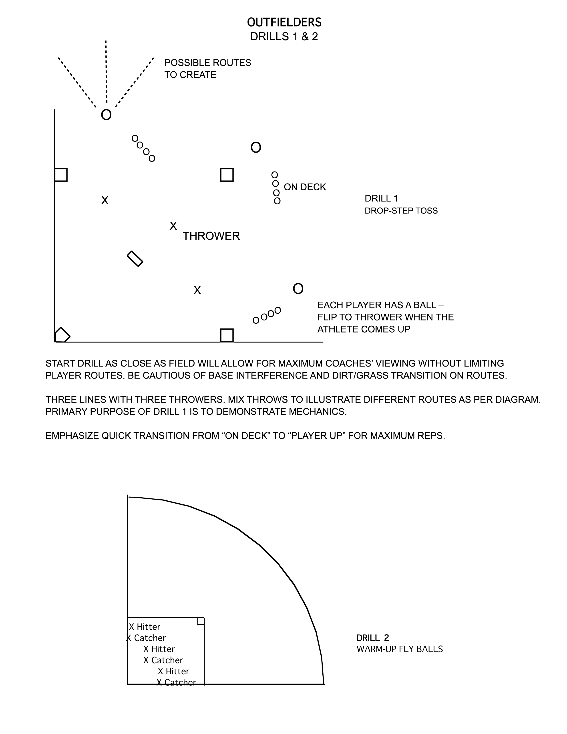

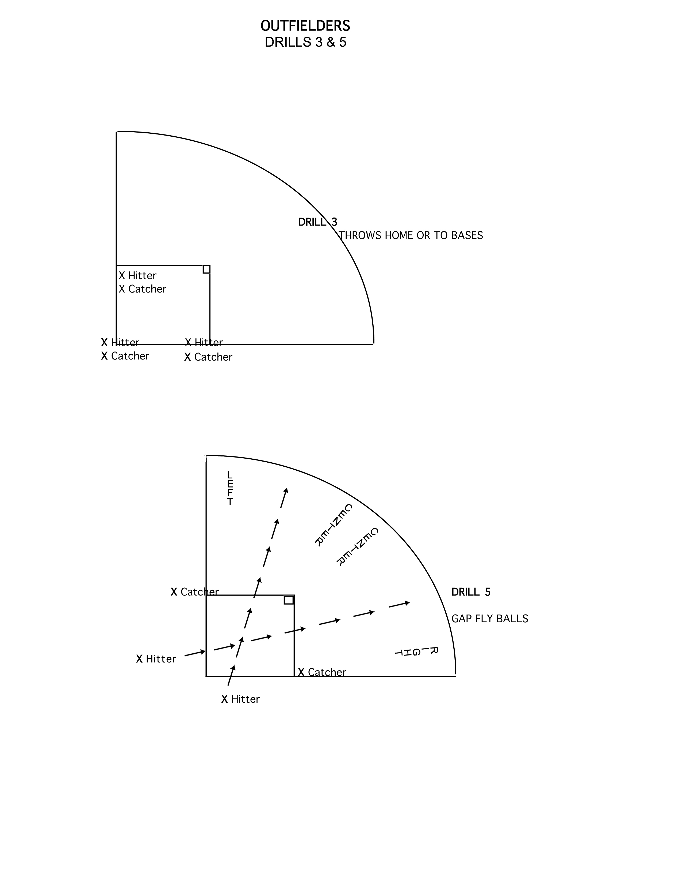

CATCHER STAFF NOTES

Staff = 5

1. Get the Catchers in numerical order. Split them into 3 equal numerically ordered groups with each group told to remember their assigned number. Call them to each rotation by their group number.

2. Confirm the correct rotation on your field at the start of each rotation and give directions to the next field at the end of each rotation.

3. The quality of the side drills are very important. Don’t roll the bunts out too far. Fly balls should have good elevation and be thrown behind the catcher forcing her to turn around to find it.

4. On drill 1: Use a megaphone to announce each time.

5. On drill 2: Both side drill staff people need to watch their lines to keep them even. All balls end with a throw.

6. On drill 3, 4, and 5: (Please see Catcher Drills explanation page for Drill 4 and 5) Staff pitchers need to pitch the ball at the same time so catcher’s throws are at the same time. Instruct catchers to rotate lines. Each drill lasts until each catcher has thrown from both home plates. Be alert to where the catchers are waiting in line. Keep their lines running down each baseline towards the dugouts. If you are not careful, the waiting participants will block the view of college coaches who are seated behind home plate.

7. On Drill 4, emphasize blocking technique with R on 1B. Pitcher should throw ball in dirt towards catcher’s knees to force some lateral movement.

8. It will make recording much faster if you get your groups in numerical order before starting the skills.

9. Bring all equipment to the pitching demonstration field at the completion of this session. If the pitching demonstration field is on the field used for session 1 outfield, move all equipment to the dugout and stay on this field as other staff will be arriving.

10. After catchers have completed POP TIMES, regroup both lines in numerical order for balance of session to aid in coach viewing.

CATCHER DRILLS

STAFF 5 2 Pitchers EQUIPMENT: 6 Throw down bases (4 home plates and 2 regular)
2 Staff for sideline drills 2 buckets of balls (40)
1 Announcer 3 empty buckets
1 Recorder 1 stopwatch
Timer for catcher 1 Clipboard w results sheet/pencils Measuring Tape
Megaphone
FORMAT:
DRILL 1 & 2 OCCUR AT THE SAME TIME. WHEN ALL CATCHERS HAVE 3 TIMES RECORDED, MOVE TO DRILL 3,4, & 5

DRILL 1: CATCHER’S TIMED THROW TO 2B (1 pitcher, 1 watch & announcer and 1 recorder) KEEP PLAYERS IN LINE ACCORDING TO THEIR CAMP NUMBER. WORK WITH GROUPS OF FOUR, 2 THROWING, 2 CATCHING & THEN ROTATE. RECORD 3 TIMES: TIME FROM "POP" OF CATCHERS GLOVE TO CONTACT OF GLOVE AT 2B. ANNOUNCE TIMES WITH MEGAPHONE

DRILL 2: SPLIT ALL OTHER CATCHERS IN 1/2 (3B line & 1B line. Keep lines even during this drill and end each drill with a throw to the appropriate base). KEEP PLAYERS WARM AND DISPLAY THE FOLLOWING CATCHING SKILLS:
1. BUNTS: DROP BALL OVER SHOULDER KEEPING BALL CLOSE TO HOME PLATE

2. POP UPS: STAND BEHIND CATCHER. THROW BALL UP WITH GOOD ELEVATION BEHIND CATCHER.. YELL “BALL” WHILE IN THE AIR FORCING HER TO FIND BALL.

3. BLOCKS: STAND OUT IN FRONT OF CATCHER AS PITCHER THROWS BALLS IN THE DIRT FORCING HER TO BLOCK.
NOTE: CONTINUE CYCLING THROUGH THESE 3 DRILLS. ABOUT 12 BALLS PER DRILL UNTIL DRILL 1 IS COMPLETE. IT IS IMPORTANT TO KEEP ROTATING DRILLS.

DRILL 3: AFTER TIMING IS COMPLETE:
USE 2 STAFF PITCHERS ON EACH SIDE OF MOUND AND STATION NOTE: During drill 3,
CATCHERS ON EACH SIDE OF HOME PLATE Keep catcher’s lines
From obstructing the view
PITCHERS THROW AT SAME TIME (CATCHERS RECEIVE 2 of coaches behind the backstop.
PITCHES THEN ROTATE). Reorder numerically for this drill

3B CATCHER THROWS FIRST PITCH TO 3B AND SECOND PITCH TO 2B 1B CATCHER THROWS TO 2B THEN 1B. (STAFF RECEIVES AT ALL 3 BASES) TRY TO GET ALL PLAYERS THROUGH BOTH SIDES

DRILL 4: USE 2 PITCHERS ON EACH SIDE OF MOUND
THROW 3 CONSECUTIVE BALLS IN DIRT TO EACH CATCHER. CATCHER BLOCKS AND DOES NOT THROW, BUT SHOULD BLOCK AS IF RUNNER IS ON 3RD. CATCHERS ROTATE ONE TIME THRU EACH LINE.
DRILL 5: DEMO THROW FROM KNEE OR KNEES
USE TWO PITCHERS AND TWO STAFF CATCHERS AT 1B AND 3B. PITCHERS THROW TOGETHER; THE TWO CATCHERS THROW TO THE NEAREST CORNER FROM THEIR KNEES. THEN THEY SWAP SIDES AND RECEIVE SECOND PITCH AND THROW TO THE NEAREST CORNER.

DRILL 6: PICKOFF OR STEAL
USE ONE STAFF PITCHER. STAFF CATCHERS AT 1B AND 2B. BALANCE OF STAFF AS BASERUNNERS AT 1B. ALL CATCHERS LINE UP DOWN THIRD BASE SIDE AS PITCHER THROWS TO CATCHER, STAFF BASERUNNER SIMULATES A LARGE LEAD TO ENCOURAGE A PICKOFF THROW FROM CATCHER, OR SELLS A COMMITTED STEAL MOVE (WITHOUT COMPLETING FULL RUN TO 2B). CATCHERS MUST READ SUCH MOVES CREATED BY BASERUNNERS AND THROW ACCORDINGLY. ONE OR TWO TIMES THROUGH AS TIME ALLOWS. ENCOURAGE CATCHERS TO MAKE QUICK DECISIONS.

OPTIONAL DRILL 7: STAFF PITCHERS ALTERNATE THROWING WILD PITCHES
STAFF PITCHER THROWS A WILD PITCH TO THE BACKSTOP WHILE ANOTHER STAFF PERSON SETS UP AS THE PITCHER COVERING HOME. CATCHER STARTS FROM STANCE, RETRIEVES THE BALL AND THROWS TO THE PITCHER COVERING THE PLATE. CATCHERS WORK IN PAIRS WITH EACH TAKING TWO BALLS.

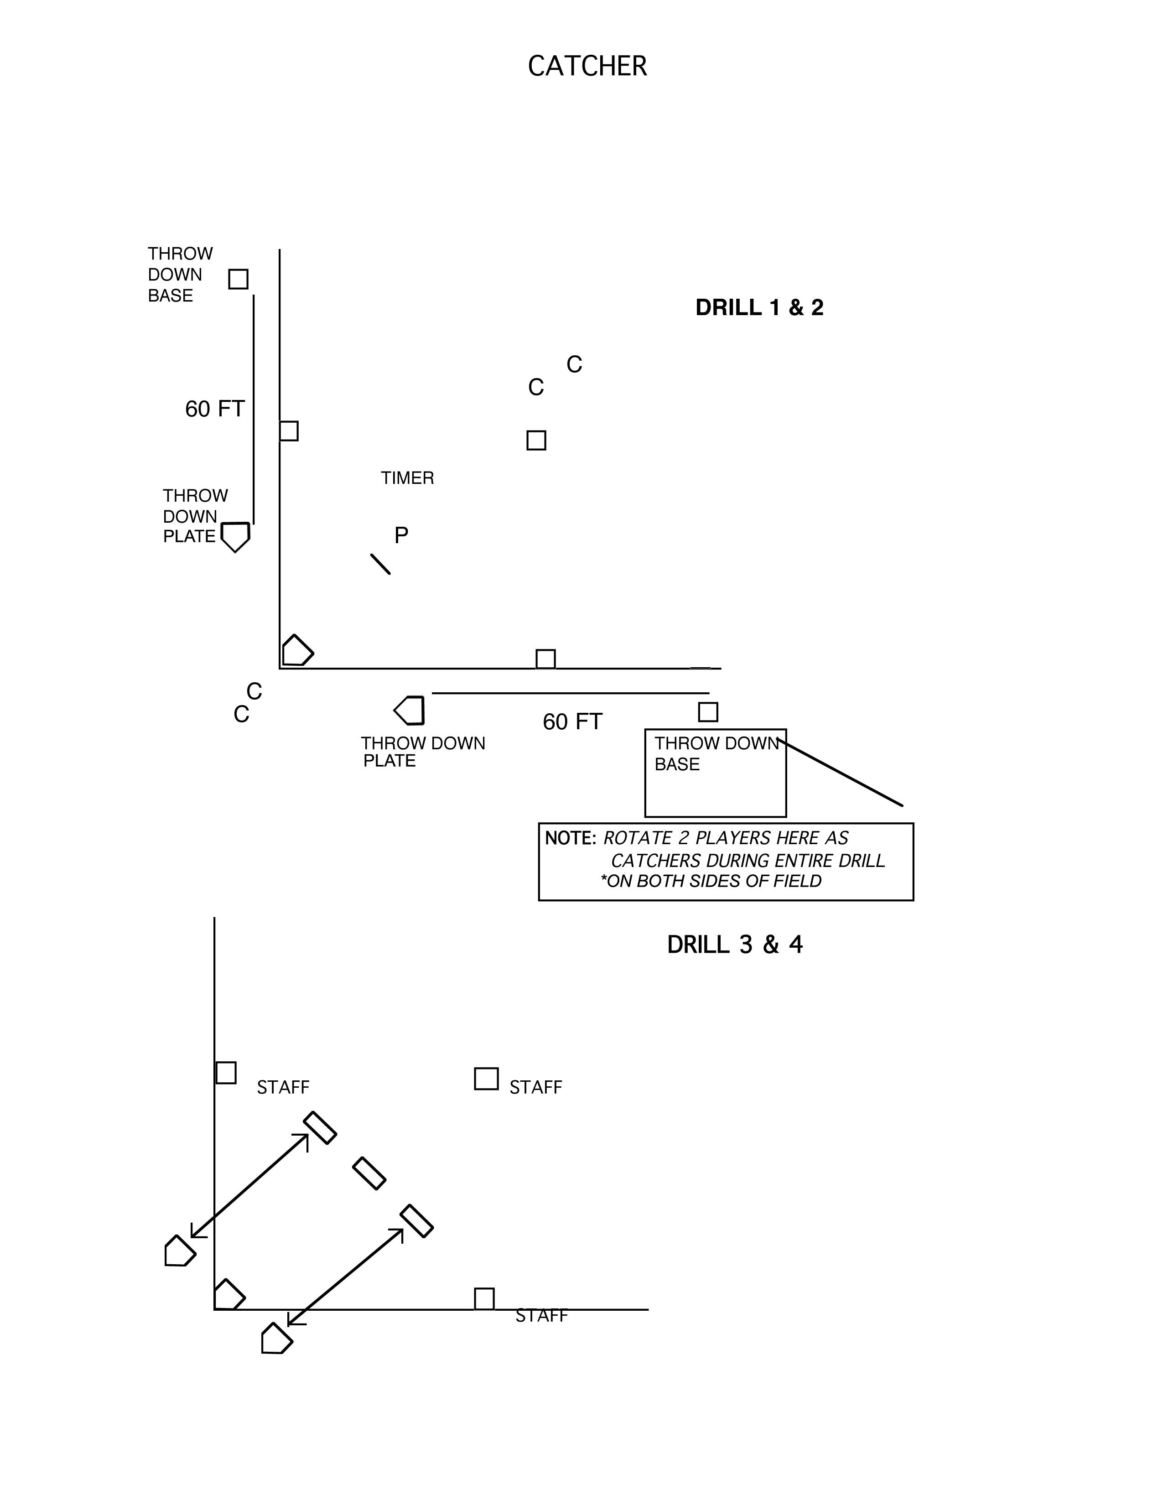

FORMAT - SESSION 2

PITCHERS

8:30-11:00 On-Site Check-In

11:00-11:20 Walk-Up Registration

11:30-11:40 Introduction of staff and explanation of field rotations

11:40-11:45 Field manager gives field instructions

11:45-12:25 First rotation

12:25-12:30 Water break; rotate fields

12:30-12:35 Field manager gives field instructions

12:35-1:15 Second rotation

1:15-1:20 Water break; rotate fields

1:20-1:25 Field manager gives field instructions

1:25-2:05 Third rotation

2:05-2:10 Water break

2:10-2:25 Student-athlete and parent information sessions

PITCHER STAFF NOTES
Staff = 9

1. Get the Pitchers in numerical order. Split them into 3 equal numerically ordered groups with each group told to remember their number. Call them to each rotation by their group number.

2. Confirm the correct rotation on your field at the start of each rotation and give campers the directions to next field at the end of each rotation.

3. Radar gun must be retrieved from the running field & brought to the pitching field for this session. Return the gun to the running field after session 2 is complete.

4. Allow around 15 pitchers with their catchers in the outfield at any one time. These pitchers are to be warming up for their showcase time at the 9 rubbers in the infield. Keep the remainder of the pitcher/catchers in a group around foul territory of 3B. Shuttle more pitchers/catchers into the outfield as the 15 rotate around to the infield.

5. Catchers must not be allowed to chase loose balls. Staff located behind rubbers must throw pitchers another ball when necessary.

6. At rubber #2, announce all 4 pitch speeds with the megaphone.

7. All rubbers set at 43 feet. Announcer and recorder position themselves behind the backstop. The radar gun person positions herself at the net behind catcher #2.

8. At rubber #5, the pitcher throws 4 pitches (2 of her 1st best pitch and 2 of her 2nd best pitch). After all 4 pitches have been thrown, announce the 2 pitch types and fastest time for each. Record all 4 times and both pitch types. Announcer stands behind the pitcher. Radar gun person and recorder stand at the net behind catcher #5.

9. Staff behind rubbers must keep on deck pitcher and catcher close and ready to jump in when warm-up rubber opens up.

10. Staff behind rubbers must monitor pitchers in the outfield. Keep them rotating around to first base.

11. As pitchers complete rubber #9, bring them around to next rubber (#10) as shown in the diagram. Ask catchers to catch for the staff hitter. Station two more staff to catch throws at a measured 2nd and 3rd base. Hit the pitcher four ground balls to field and throw to 2nd and 3rd.

12. Use only camp supplied balls rather than the pitcher’s personal ball. Distribute these camp balls when the pitchers first take the field for warm-up and collect them as each pitcher rotates through the ground ball station (# 10).

13. Keep all staff in place until the last pitcher completes her ten-station rotation. This practice just avoids distractions for the last pitcher coming through the pitching stations.

14. Be extremely careful not to make recording errors. Pitchers will be coming through in numerical order, but no-shows will create skipped numbers. Have the radar operator verbalize the pitcher ‘s number for the recorder so skipped numbers don’t create recording errors.

PITCHER DRILLS
Staff: 9

Equipment: 10 Home Plates 2-3 Radar Guns Tape Measure
10 Pitching Rubbers 2 Megaphones 2 Clipboards/Record Sheets
1 large net for #5 3 Empty Buckets 8 Two-Sided Signs
1 small net for #2 3 Buckets of Balls

To ensure our ability to keep the needed flow through these ten stations, any of the nine rubbers (excluding #5) may be subject to two or three pitches instead of four.

Note: 1 Radar Gun must be retrieved from running field. (Pitchers are not clocked on the overhand throw) (A third gun is good in case of a malfunction).

Note: Rubbers #2 & 5 must have 3 staff (1 Radar,1 Recorder, 1 Announcer)

Note: 3 staff must work behind the rubbers to keep everything flowing - Push athletes along and answer questions. Keep outfield circling around to the warm-up rubber.

Note: Catchers must not be allowed to chase loose balls. Staff behind rubbers will supply balls to pitchers when necessary.

Note: Staff must collect all balls at the end of each rotation.

Note: 2-sided signs should be hung on the backstop to identify pitches.

Note: Use nine pitching stations and one fielding station only if your infield is big enough to accommodate. If not, go back to 7 stations, using the radar at #2 and #4 and eliminate the repetitive pitches.

PITCHING FIELD LAYOUT
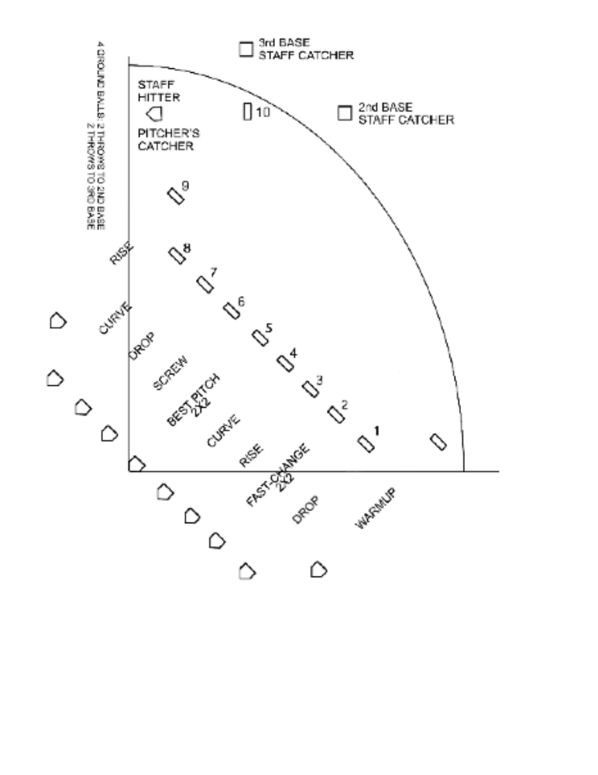(4 PITCHES AT EACH RUBBER)

Note: At #2, record two fastballs and two change-ups and announce the best speed for each. At #5, each pitcher throws their two best pitches twice (i.e. two drops, two rises). The pitch type and the best speed for each is announced.

Use only seven pitching positions if field size is limited due to inadequate space between backstop and home plate. If using seven positions, use the following format:

#1 – Drop #5 – Screw
#2 – Fastball-Change (2 Fast, 2 Change) #6 – Drop
#3 – Rise #7 – Curve
#4 (permanent rubber) – Best pitch

FORMAT - SESSION 3
INFIELDERS

11:00-2:00 On-Site Check-In

2:00-2:20 Walk-Up Registration

2:25-2:35 Introduction of staff and explanation of field rotations

2:35-2:40 Field manager gives field instructions

2:40-3:20 First rotation

3:20-3:25 Water break; rotate fields

3:25-3:30 Field manager gives field instruction

3:30-4:10 Second rotation

4:10-4:15 Water break; rotate fields

4:15-4:20 Field manager gives field instructions

4:20-5:00 Third rotation

5:00-5:05 Water break

5:05-5:20 Student-athlete and parent information session

INFIELDER STAFF NOTES
Staff = 8

1. Split Infielders into three equal groups by the following method: With all infielders together, create four lines by position. Get all four positions in numerical order. Now, divide each line into thirds. The first third of each line becomes group 1. The second third of each line becomes group two and the last third becomes group three. As each group cycles to their defensive field, place each position line in numerical order to begin the session.

2. Confirm the correct rotation on your field at the start of each rotation and give campers the directions to next field at the end of each rotation.

3. Use one staff member to direct staff hitters in the drill sequences. This person should be a leader and very vocal in her commands. This leadership will prevent losing time moving from one drill to the next.

4. At the same time the staff is being instructed, 2 other staff members should be instructing the infielders. One talks to 3B & SS while another talks to 2B & 1B.

5. Drill 1: Keep all players deep and hit balls crisp to prevent them from running into a cross throw.

6. Drill 2A: Keep SS deep & 3B in tight to prevent 3B from throwing into SS.

7. Drill 2B & 2C: Good time to hit towards base with ground balls on both drills to allow campers to turn a more textbook double-play. Staff at 1B should be verbal on all plays to keep attention on her rather than real 1B.

8. Drill 2D & E: Use mock batting stance then square. Roll bunt to player. This helps corners key on when to start charging. (Situation: No outs--R on 1B)

9. Drill 2E: Important to alternate corners to keep all throwing lanes clear. Suggest a staff member stand by 1B. Communicate when to move into place to receive bunt. Go through each drill twice if time permits.

10. Quality ground balls is extremely critical. Understand that the ability to hit flat ground balls to the backhand side or glove side is required.

11. Be alert to the angle of a hit in keeping this environment safe and know where to stand. Should you hit to glove side or backhand. Each drill will show you where and how to hit to keep everyone safe. Adjust as you see these things. Look at the curved arrow on the infield diagrams. This is the recommended shift for staff hitters to help create a better angle.

- Keep a bucket at each base. When the bucket is full, run it in to the plate in exchange for an empty one.

- Camps of 100 infielders or less should use only 2 hitters instead of 3.
INFIELDER DRILLS

STAFF 8 4 Good Ground Ball Hitters EQUIPMENT: 3 bats
1 Catcher at deep 1B 60 balls in 3 buckets
3 Staff to instruct 3 empty buckets
Stopwatch
Throw down base
FORMAT: Players go to position of choice
10 minutes Drill 1: CROSS FIRE
3 HITTERS/3 CATCHERS (See Drill 1 Diagram)

Begin by hitting routine grounders; After 5 minutes, progress to hitting more challenging grounders

DRILL 2: CROSS FIRE
2 HITTERS/2 CATCHERS 1X thru
NOTE: The longest line will dictate timing.

- SS (PLAY DEEP) TO 1B
3B to 2B

B) 1B to 3B
2B to SS (@2B) – SS to *staff 1B
*(Staff Person is located 10 feet behind 1st base) (Use net to protect Staff 1B)

C) 3B TO 1B
SS TO 2B (@ 2B) - 2B TO *STAFF 1B
*(Staff Person is located 10 feet behind 1st base) (Use net to protect Staff 1B)

D) 3B BUNT TO SS (@2B)
1B BUNT TO 2B(@ 1B)

E) 3B BUNT TO 2B (@ 1B) NOTE: DRILL E - Alternate one bunt at a
1B Bunt to SS (@ 2B) time so 3B is not throwing to 1B with 1B in the way. (Drop to 1 hitter and 1 thrower)
DRILL 3: DP'S / GROUNDERS, THROW AROUND
1 HITTER/1 CATCHER

(1) 5 - 4 - 3 - 6 (AT 2B) - 2 NOTE: HIT TO 5/6 HOLE FOR 3B
(2) 6 - 4 - 3 - 5 - 2 NOTE: HIT TO GLOVE SIDE OF SS
(3) 4 - 6 - 3 - 5 – 3 - 2 NOTE: HIT TO BACKHAND SIDE OF 2B
(4) 3 - 6 (AT 2B) - 4 (AT 1B) 5 - 6 (AT 2B) - 2 NOTE: HIT TO 4/3 HOLE

If Time Remains:

Drill 4: RETURN TO DRILL 1 WITH 2 HITTERS AND 2 CATCHERS. ALTERNATE 3B/SS AND 1B/2B.

Note: Balls should be returned to buckets at the end of this session.
Note: Staff members not actively involved in these drills are responsible for taking the buckets as they fill at each base to the hitters at the plate and bringing empty buckets back to the bases.
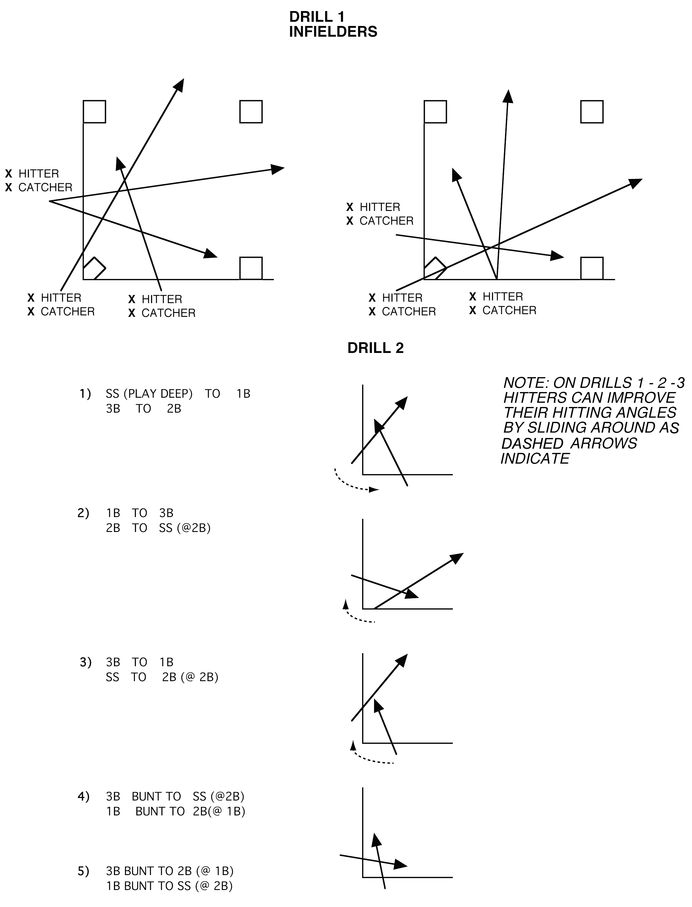

OFFENSIVE FIELD NOTES
ALL SESSIONS

Staff: 2 for Session 1
3 for Session 2 & 3

1. Confirm group number when players arrive, especially during session 1. This session creates some confusion with the combination of outfielders and catchers.

2. Quickly get your group in numerical order. Divide them into 2 groups. Put one on first base side and the other on third base side. Lefty’s must hit from 1B side so swap any lefty’s on 3B side with the same largest # player on 1B side. Have both lines come to bat in this order.

3. A full camp of 130+ athletes will allow for 12-14 swings. Smaller numbers, of course, will allow for more swings. Please establish this number and be consistent. Batters may execute as desired with bunts, slaps and hits. Lefties may slap or hit.

4. Feed balls evenly with the same rhythm. Our goal is to offer the easiest possible pitch to hit. Make adjustments on the pitching machine as often as is necessary.

5. Use campers as shaggers to re-bucket balls as necessary.

6. Keep shaggers positioned on the same 1/2 of the field as they hit.

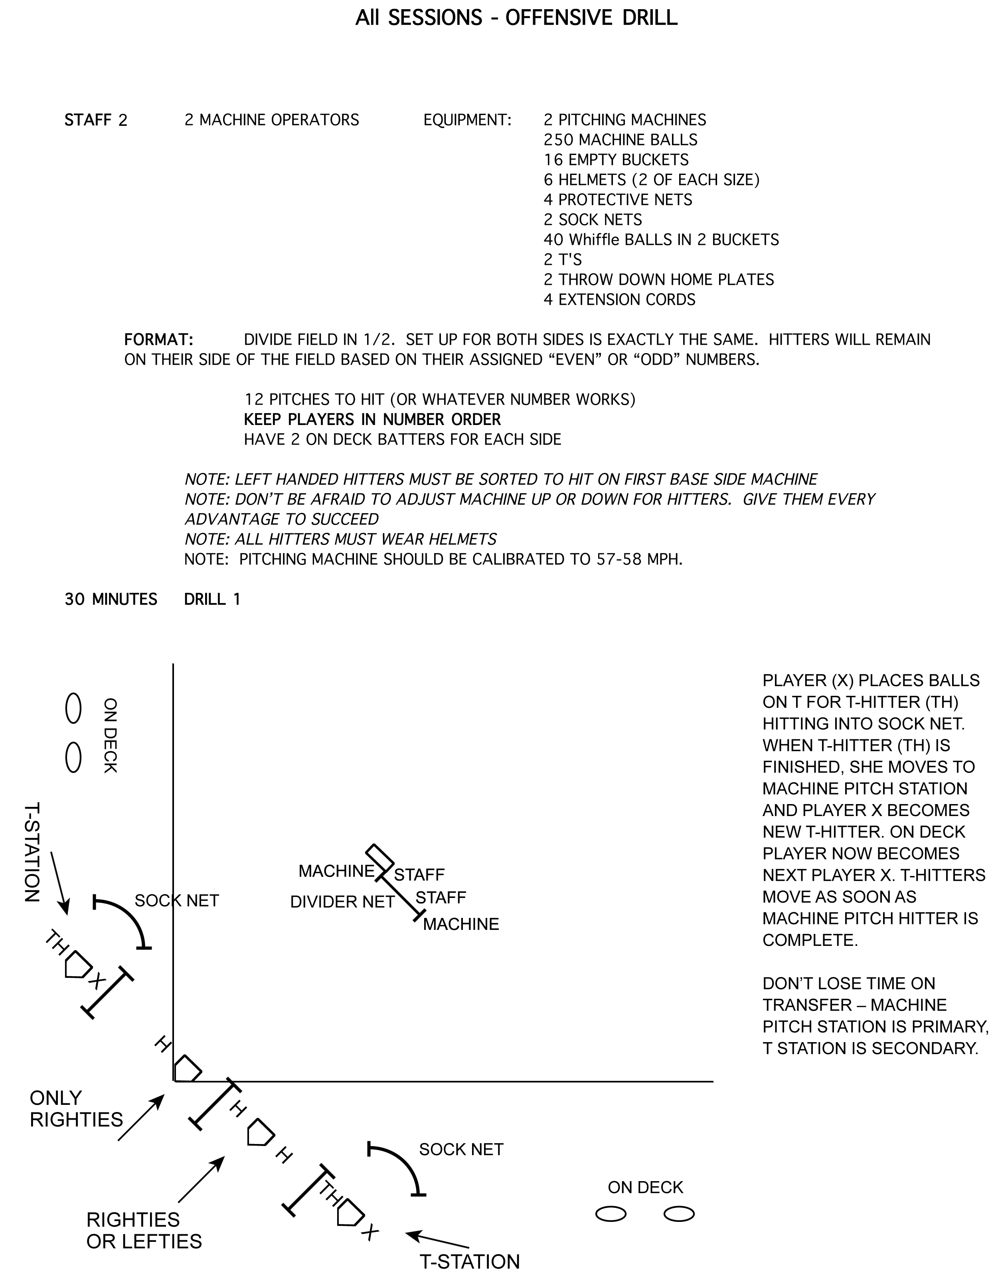

All SESSIONS TIMED SPRINTS

Staff: 1 for Session 1 Equipment: Clipboard with record sheets/Pencil
2 for Sessions 2 & 3 Stopwatch

Format: Time 2 Sprints from H to 1B or from 1B to 2B.

This is a 60-foot sprint. Athlete may start on 1B and time to 2B or may start at home and time to 1B. If timing from home, all runners must start in the right batters box with feet in batting stance position. The watch starts at the plant of the 1st step.

Athlete begins sprint at her discretion. If starting at 1B, she must be in contact with 1B. Stopwatch is started as the base foot hits the ground on the first step. Stopwatch stops at contact with 2B. Timer positions nearer to 2B and records both sprint times.

Be consistent on sprint start location, either from home or 1B.

Time 1 Sprint from Home to Home.

Athlete begins sprint at her discretion. All runners (lefties included) start in right batters box. Feet should be in batting stance position. Stopwatch is started as the first step foot hits the ground. Runner must touch all bases in order for her time to be recorded. Timer is positioned near the plate and records the time.

Divide players on this field into 2 groups -1/2 run while 1/2 overhand throw and then rotate. (First session should remain as outfielders in one group and catchers in the other). It will make recording much faster if you get your groups in numerical order before starting to time.

Recorder should indicate reason on the record sheet when a player chooses not to run, for example, sick or hurt.

It is critical that recording errors not be made. Be aware that there will be some skips in the number sequence due to no-shows on camp day. So, be sure to always verify the athlete number before recording results.

Timed running for pitchers is optional. They may choose not to participate.

OVERHAND THROW
(For Catchers, Outfielders and Infielders Only)
ALL SESSIONS

Equipment: 1 Radar Gun
Tape Measure
1 Instant Net
Empty Bucket for Recorder to Sit On
1 Pitching Rubber
Clipboard with Record Sheets/Pencil
40 Balls in 2 Buckets

Format: The overhand throw is clocked on the sprint field. Nail 1 pitching rubber in the outfield grass to provide the start line. A sock net should be set 40 feet from the rubber and positioned so that balls are thrown in the direction of the outfield fence. Athletes may take a running start, may crow-hop or may just step and throw to the target (net). They may not contact the grass on the net side of the rubber as a result of the throw or follow-thru. Thrown ball must hit the net in order to be recorded. Balls missing the net are recorded as a scratch.

Allow a couple of minutes for athletes to warm-up throwing.

Staff person should set up behind the net and gun 2 throws.

Pitchers in session 2 will not execute this skill. (After session 1, bring radar gun to the pitching field to be used at the 2nd gun location for pitchers. Retrieve it at the end of session 2 and deliver it back to the overhand throw station for session 3.

Divide players on this field into 2 groups -1/2 run while 1/2 overhand throw and then rotate. (First session should remain as outfielders in one group and catchers in the other).

It will make recording much faster if you get your groups in numerical order before starting the skills.

Exhibits

EXHIBITS BY NUMBER

1) EQUIPMENT LIST

2) QUICK FACTS SHEET

3) GENERAL CAMP INFORMATION SHEET

4) RECRUITING CAMP BROCHURE

5) NFCA LOGO

6) CAMP T-SHIRT DESIGN

7) PARTICIPANT NUMBERS

8) ACCEPTANCE LETTERS (3)

9) STUDENT-ATHLETE INFORMATION BOOKLET

10) PAYMENT/ INSURANCE FORM

11) STUDENT-ATHLETE EVALUATION FORM

12) COACH EVALUATION FORM

13) TESTING RESULTS

14) TRAINER’S INJURY REPORT FORM

15) TESTING DESCRIPTIONS

EXHIBIT 1
EQUIPMENT ITEMS TO TAKE TO
RECRUITING CAMPS

For the Hitting Field:
- two (2) straight, protective screens (One between batters, one at pitching machines)
2. two (2) straight screens and two (2) catch net screens for the T-hitters
3 one (1) screen (any kind) behind 2B for shaggers to throw to catch-in person
Total screens: 8 Maximum
4. two (2) pitching machines
- four (4) extension cords
- tape to keep extension cords secure to ground so passers-by do not trip
- pitching machine balls - 250 16 buckets
- two (2) throw down home plates
- 2 buckets of wiffle balls - 40
- two (2) tees
- 20 or so empty buckets - for shag, pitching, and warm-up hitting stations
- a few bats - but everyone usually brings their own
- some batting helmets (one of each size) - everyone usually brings their own

For the Infield Field:
- four (4) bats for fungo hitters
- three (3) buckets of balls (60 balls) & fifteen (15) empty buckets
3. one (1) throw down base

For the Pitching Field:
- nine (9) staked down pitching rubbers at 43’ + the main field rubber
- two (2) protective screens: behind catchers at #6 & at #9 positions
- (2) radar guns (a third in reserve would be great)
- four (4) buckets for the recorders and gun operators to sit on
- three (3) buckets (60 balls) of good balls for pitchers
- two (2) clip boards
- charts and pencils
- tape measure
- nine (9) throw down home plates
- Signs: Nine two-sided (Curve (2), Screw, Drop (2), Fast/Change, Rise (2), Best Pitch)
- two (2) megaphones

For the Catcher Field:
- two (2) buckets of balls (40 balls) & Three (3) empty buckets
- one (1) good stop watch
- one (1) clipboard
- charts and pencils
- six (6) throw down bases (4 plates and 2 bases)
- tape measure
- 7. one (1) megaphone

For the Outfielders:
1. three (3) bats
2. 60 balls in 3 buckets
- three empty buckets
- one (1) stop watch

For the Overhand Throw:
1. one (1) instant net
2. one (1) radar gun
3. one (1) bucket of balls
one (1) pitching rubber to use as the starting line
4. tape measure
5. empty bucket for recorder to sit on
- record sheets, pencil, clipboard

For the Timed Running area:
- two (2) good stop watches
- two (2) clipboards
- charts and pencils

General Items
- name tags (for camp staff)
- extra set of throw down bases
- water cups
- five (5) walkie talkies
- trainer
- staff T-shirts
- hammer

Summary
- screens - Total 8 5 straight + 2 sock + 1 either
- 2 pitching machines + extension cords
- 250 pitching machine balls
- 108 game balls
- 40 wiffle balls
- 30 buckets
7. 9 home plates
9 pitching rubbers with nail down spikes
3 sets of throw down bases
- 4 helmets
- 6 bats
- 2 radar guns (3, if possible)
- tape measure
- 6 clip boards
- nine 2-sided signs
- 3 stop watches
- 2 megaphones
15. 2 Tees
EXHIBIT 2
NFCA/PENNSBURY RECRUITING CAMP QUICK FACTS

June 18, 2009 – LMT Softball Complex
pennsburyinvitational.com
Date/Location:
The camp will be held on Thursday, June 18 at LMT Softball Complex, Oxford Valley Rd. (intersection of Roelofs & Oxford Valley Rd, with 460 Roelofs Rd. being the closest street address). Yardley, Pennsylvania.

Participants:
Go to nfca.org and click on recruiting camps, then administered camps and then Pennsbury to view participants; the list is updated each Monday, beginning Monday, May 25.

Session Times:
The camp will be divided into the following sessions:
Outfielders/Catchers: 8:30 a.m. – 11:25 a.m.
Pitchers: 11:30 a.m. - 2:25 p.m.
Infielders: 2:25 p.m. – 5:20 p.m.
College Coach Camp and Tournament Pre- Registration: Coaches should register to recruit at the camp and tournament on-line registration at: nfca.org/camps/signup. The college coach pre-registration deadline is June 11.

On-Site Camp Check-In: Pre-registered coaches may pick up their camp/tournament coaches book, which will include a breakdown of session schedules as well as detailed information on each athlete.

Non-registered, late registered or non-NFCA member coaches will be charged a $25 fee to receive a camp book, and will get the book if any are available after registered coach check-in.

Refreshments: Please enjoy cold water and soft drinks all day compliments of the NFCA.

Basic Format: Each athlete will be assigned a number and will wear that number on the front and back of her shirt. The wristband, signifying high school graduation year, will be worn on the throwing wrist. The athletes will be led through hitting and fielding drills, which will be explained in the coaches’ book. In addition, running times, catcher pop times and pitching/overhand throw speeds will be published by athlete number on the NFCA web site within five days of the camp; please keep your coaches book for athlete number reference.

Lodging
Please use the Web site pennsburyinvitational.com for hotel information.

Directions to LMT Softball Complex from Pennsylvania International Airport:
Take I-95 N. Exit 46A, Morrisville onto Rt. 1 N. In approx. 100 yards, exit Oxford Valley and stay to the left. After turning left on Oxford Valley Road from Route 1, travel 1.2 miles to the 4th traffic light and turn right onto Oxford Valley Road. Follow for 1.2 miles, past a traffic signal at Stoney Hill Road and the fields will be on the left hand side of the street. Parking is past the fields on the left. Follow the NFCA Camp parking signs. (Check the Pennsbury web site for more detailed directions).

Camp Results:
Camp results will be posted by athlete number on the NFCA Pennsbury camp page within 5 days of camp completion.

WE LOOK FORWARD TO SEEING YOU IN YARDLEY!
EXHIBIT 3
2009 Endorsed Camp Information Sheet

Camp Name: Camp Date:

Tourney Name: Tourney Date:

Camp Complex Name: # of Fields:

Camp Complex Address:

Camp Complex City: State: Zip:

Camp Administrator:
Address:
Address (physical address for UPS shipments, if different):
City: State: Zip:
Office Phone: Home Phone:
Cell Phone: Fax:
Email Address (For NFCA Business):

Published Contact Name for CAMP Inquiries:
Published Camp Phone:
Published Email:
Published Camp Web Site Address:
Published Camp Application Deadline for 2009:

Published Contact Name for TOURNAMENT Inquiries:
Phone: Email:

NOT PUBLISHED INFORMATION:
Individual Managing the DATABASE:
Phone: Cell Phone:
Email Address:
Individual Receiving Athlete Web Applications:
Email:

Individual Receiving College Coach CAMP Registrations:
Phone: Cell Phone:
Email Address:

Individual Receiving College Coach TOURNEY Registrations:
Phone: Cell Phone:
Email Address:
EXHIBIT 4 [Example]
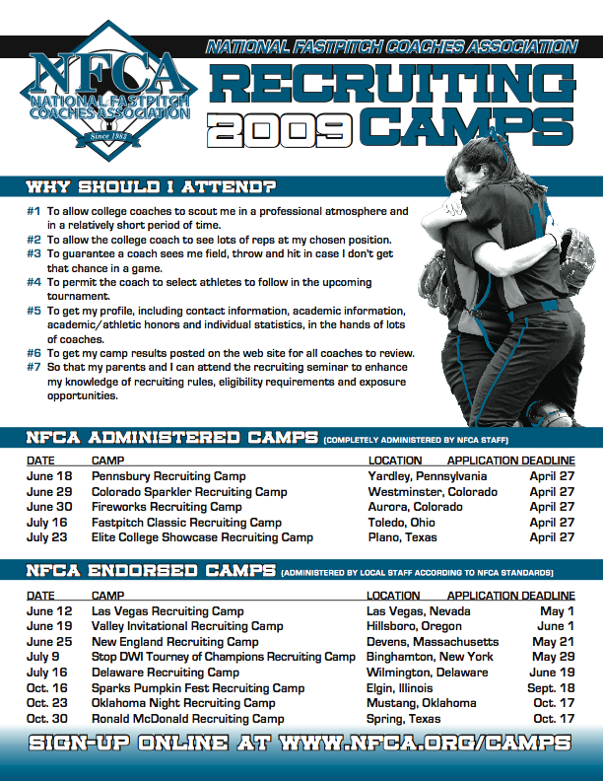
EXHIBIT 4 (CONTINUED)
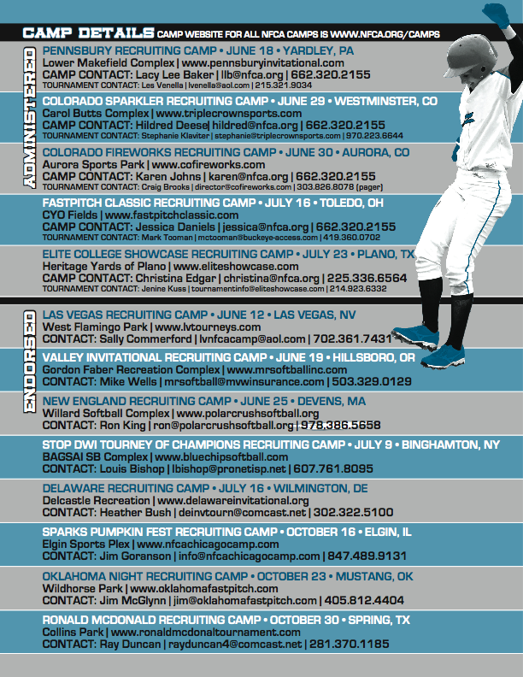
EXHIBIT 4 (CONTINUED)
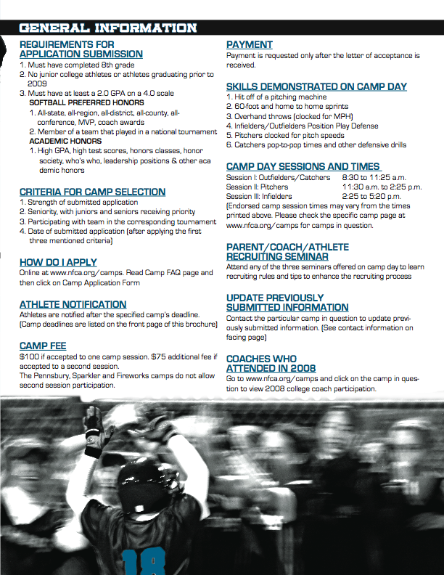
EXHIBIT 4 (CONTINUED)
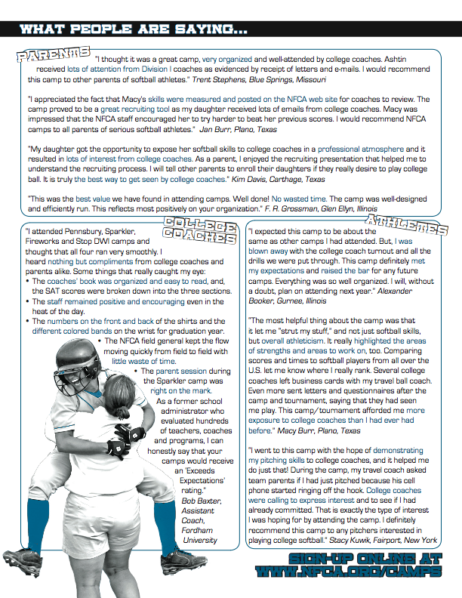
EXHIBIT 5


EXHIBIT 6
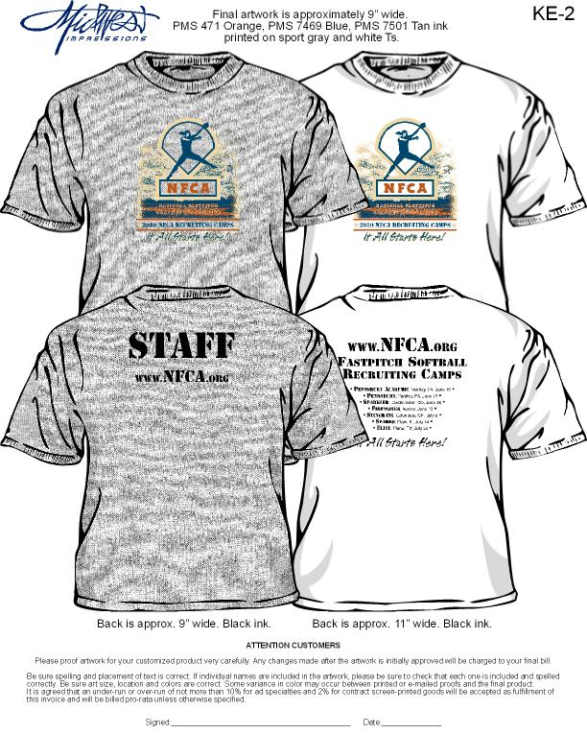
EXHIBIT 7
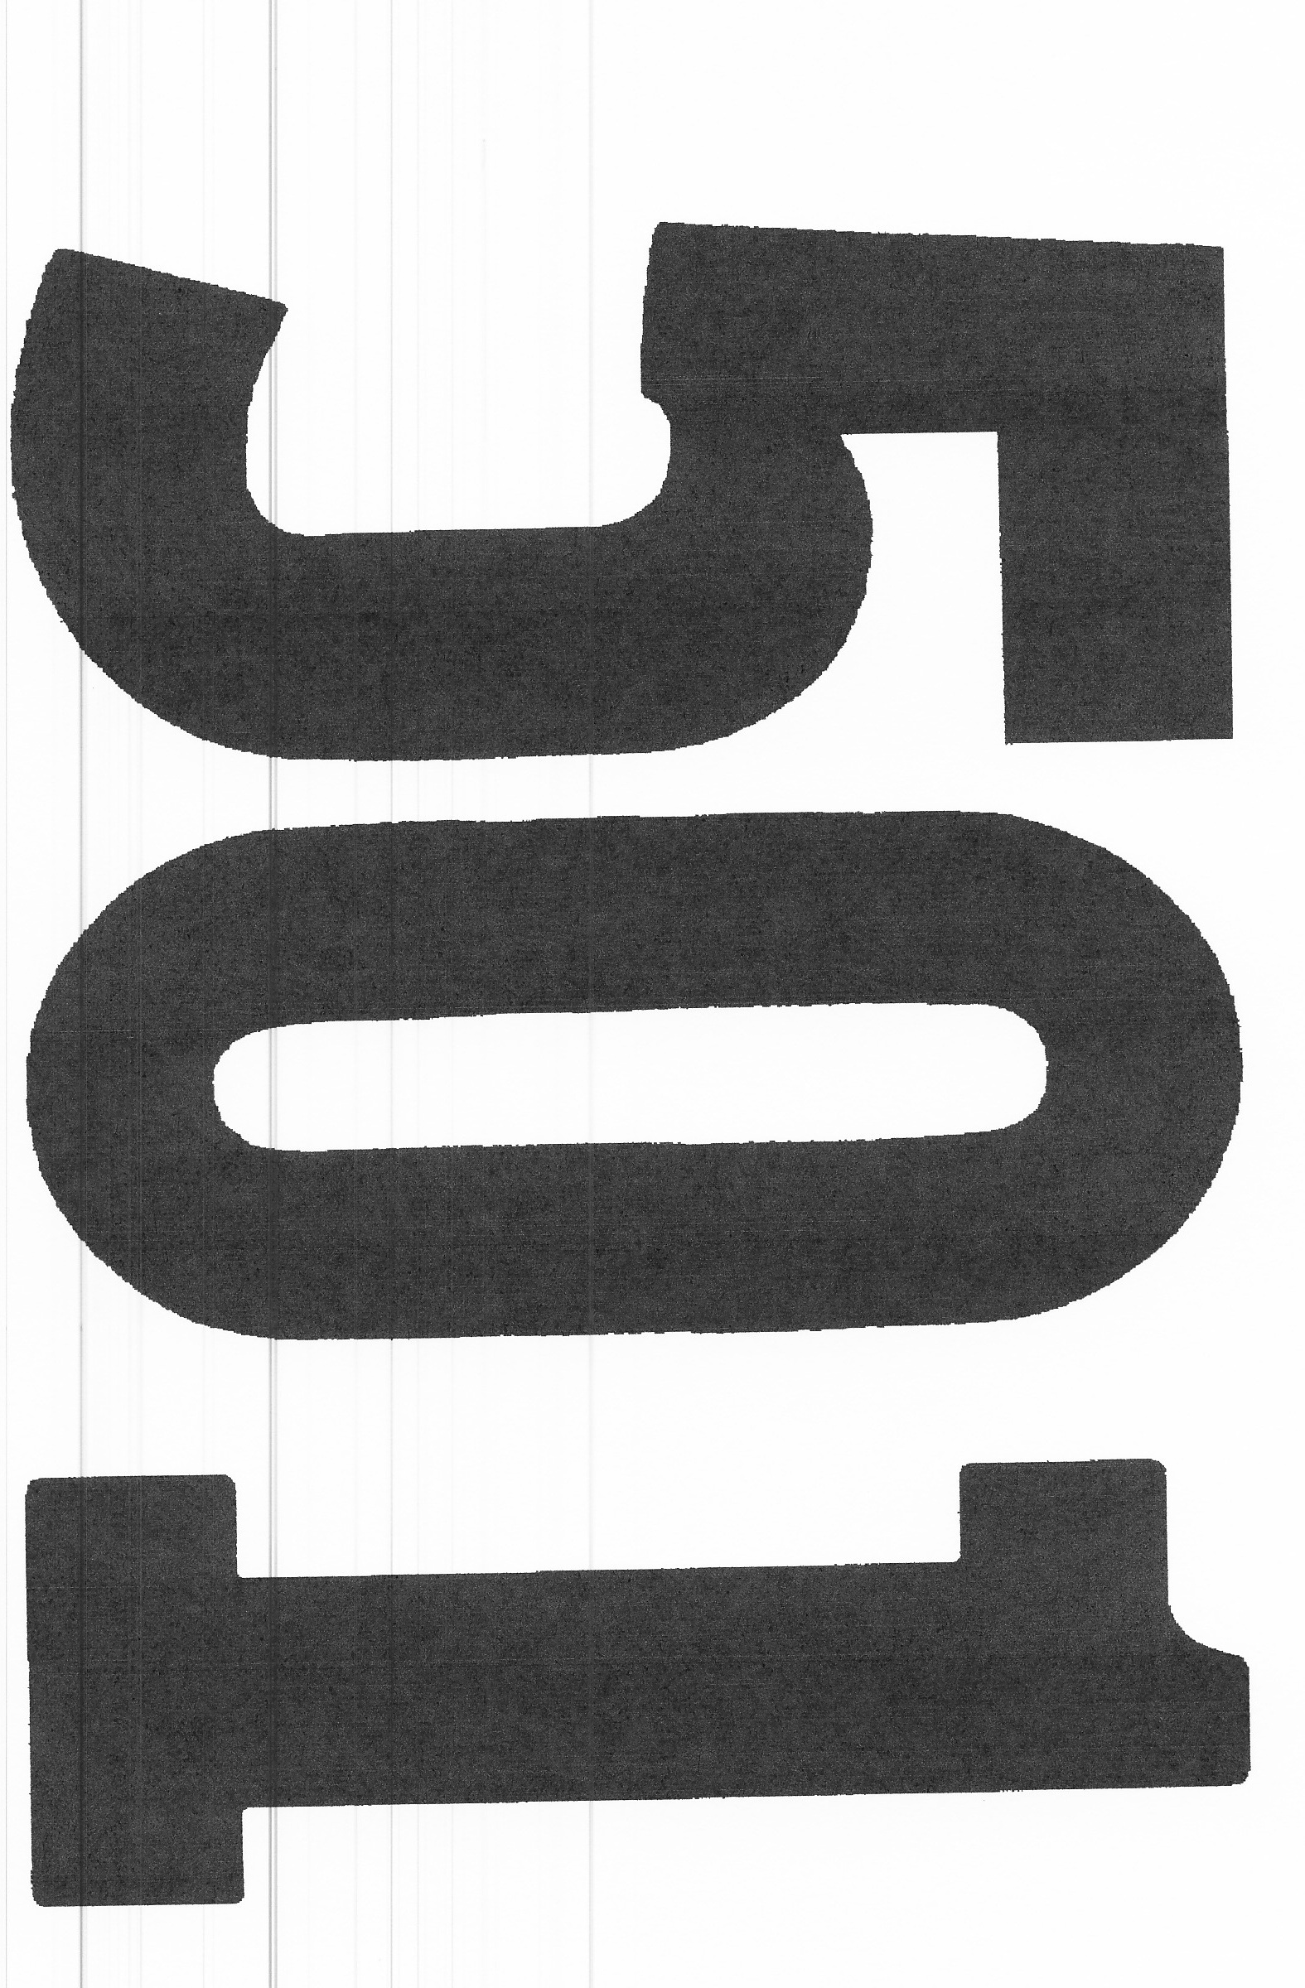
EXHIBIT 8
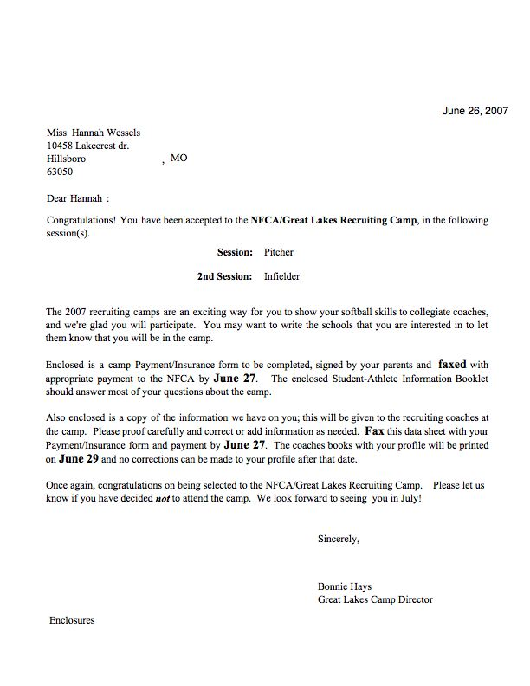
EXHIBIT 8 (CONTINUED)

May 2, 2007

Malori Comer
25 St. Joan Court
Danville, CA 94526

Dear Malori:

Thank you for your interest in the 2006 Colorado Sparkler Recruiting Camp, which has grown to be one of the premier camps in the country. In fact, the NFCA had the largest applicant turnout ever and we had to narrow the field by looking at the following factors: seniority (juniors and seniors), quality of the submitted application (statistics, honors and awards), date of submitted application, strength of academic record and tournament participation.

We are sorry to inform you that we could not include you on this year’s list of participants. We do appreciate your interest in our camp program, however.

There are other NFCA camps that are still accepting applications. Please call or email if you are interested in contact information for these camps.

The 2007 camp application process opens online at www.nfca.org February 1. We hope you will submit again next year for the camps of your choice.

Best of luck with your upcoming season.

Sincerely,

Sara Thompson
Sparkler Camp Administrator
EXHIBIT 8 (CONTINUED)

Dear :

Congratulations! You have been accepted to the NFCA/Sparkler Recruiting Camp.

Session:

The 2007 recruiting camps are an exciting way for you to show your softball skills to collegiate coaches, and we're glad you will participate. You may want to write the schools that you are interested in to let them know that you will be in the camp.

Enclosed is a camp payment/insurance form to be completed, signed by your parents and mailed with payment to the NFCA. It must be postmarked no later than May 21. The enclosed Student-Athlete Information Booklet should answer most of your questions about the camp.

Also enclosed is a copy of the information we have on you; this will be given to the recruiting coaches at the camp. Please proof carefully and correct or add information as needed. Please return with payment sheet by May 21. If you are a pitcher, you also will need to return the catcher waiver form. Please ensure that if you return the enclosed information, you are participating in the Sparkler recruiting camp in Westminster, Colorado, and NOT the Fireworks recruiting camp in Aurora, Colorado.

Once again, congratulations on being selected to the NFCA/Sparkler Recruiting Camp. Please let us know if you have decided not to attend the camp. We look forward to seeing you in June!

Sincerely,

Sara Thompson
EXHIBIT 9 [Example]
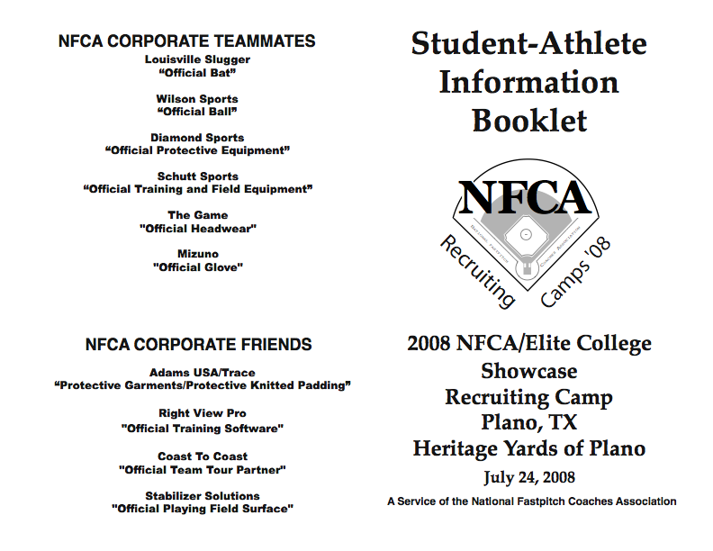
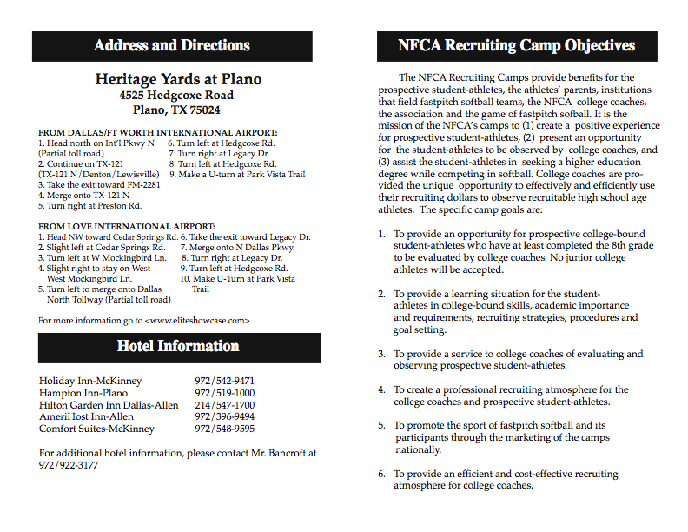
EXHIBIT 9 (CONTINUED)
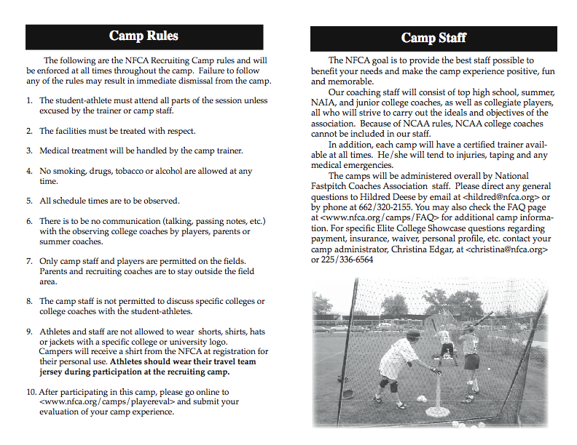
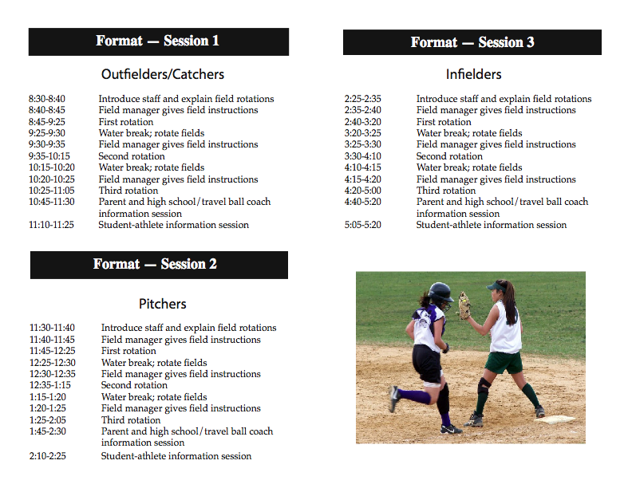
EXHIBIT 9 (CONTINUED)
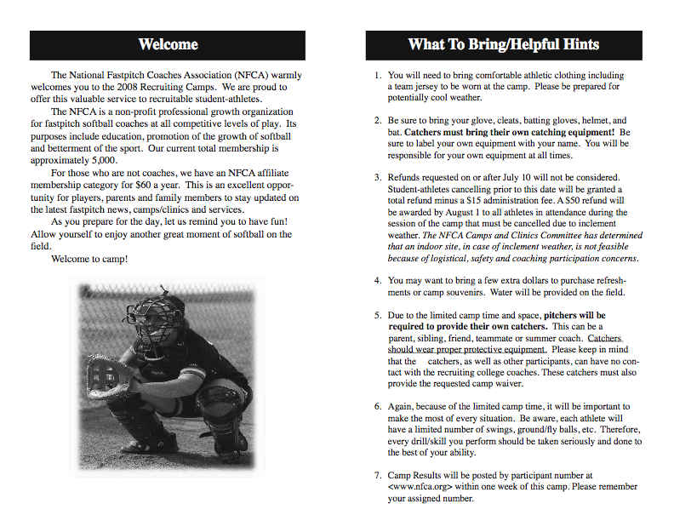
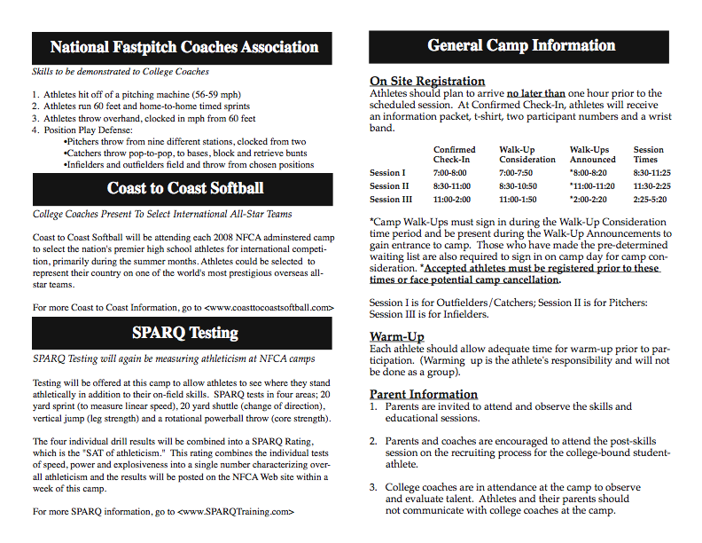
EXHIBIT 10 [Example]
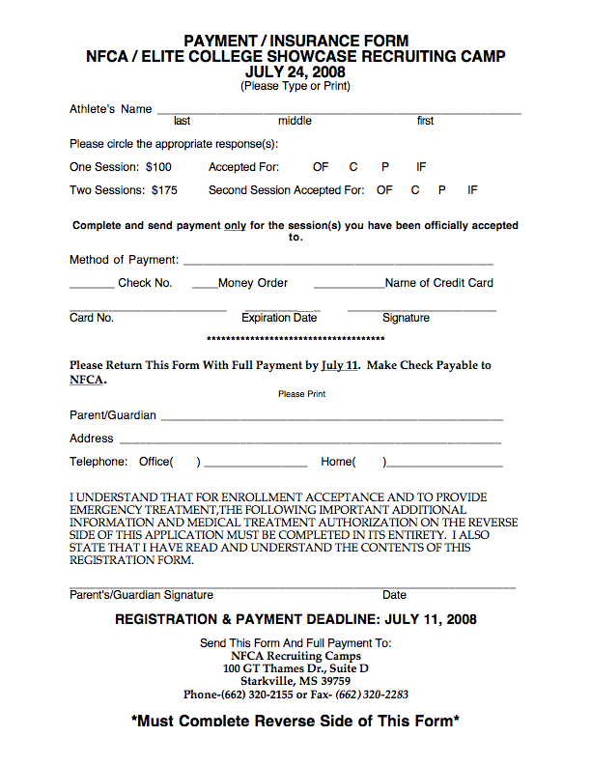
EXHIBIT 10 (CONTINUED)
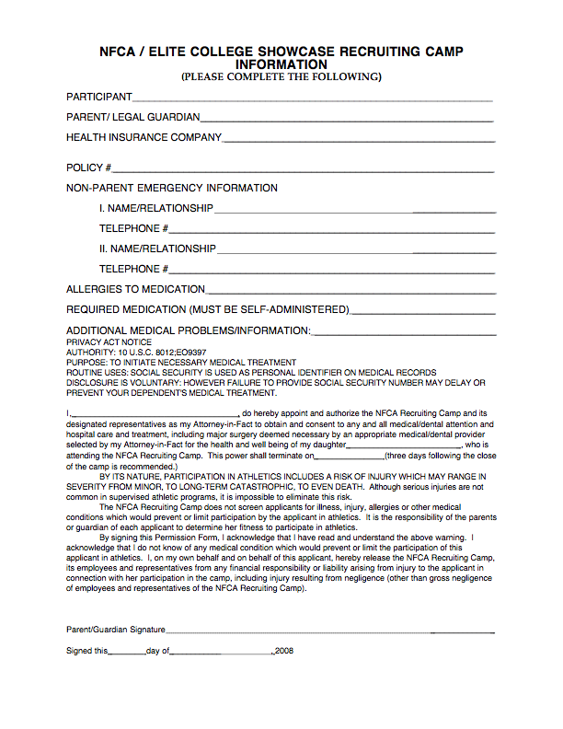
EXHIBIT 11
2014 NFCA RECRUITING CAMP EVALUATION FORM

Student-Athlete Camp Evaluation: Please circle the appropriate camp.

KC Heartland (MO) Northeast Academic (PA) Pennsbury (PA) Ohio Stingrays (OH)
Las Vegas (NV) New England (MA) Valley Invitational (OR) RR Gold (CA)

Yes No N/A
The student-athlete booklet explained the structure, format, rules and detailed camp directions/information thoroughly.

The application process was clear.

The recruiting camp brochure explained the camp objectives, applicationprocess and athlete acceptance criteria.

Please provide your solution to any problem areas listed.

Yes No N/A

The camp staff was professional, knowledgeable and positive.
If no, please explain:

The camp staff trainer took care of training needs.

The camp staff was helpful and patient in explaining rotations answering questions.

The speakers were effective, interesting and knowledgeable.

Please provide your solution to any problem areas listed.

Yes No N/A

The skills, drills and testing adequately allowed the athletes display both offensive and defensive skills.

As an athlete, I received a fair opportunity to field, hit and throw.
If no, please explain:

Please provide your solution to any problem areas listed.

*PLEASE COMPLETE THE OTHER SIDE*

EXHIBIT 11 (CONTINUED)

Yes No N/A

The camp format/schedule was appropriate and followed as printed.

Changes, if any, in the schedule were communicated to the -athletes.

Please provide your solution to any problem areas listed.

Please rate how the information on each topic will be useful to your life.

Very Useful Useful May be Useful Never Useful
Balancing Athletics and Academics
Marketing Yourself as a Player
Overview of Some NCAA Rules

Please explain any positive aspect(s) of camp.

Please explain any negative aspect(s) of camp.

Your solution:

The overall rating I would give the camp is (circle one): Excellent Good Average Poor

Other comments/ideas/suggestions

NAME: PHONE:

ADDRESS:

PLEASE RETURN EVALUATION TO THE CAMP MANAGER
OR FAX TO THE NFCA
Thank you for your input!
We will carefully review these evaluations to improve next year’s camps.

NFCA, 2641 Grinstead Dr., Louisville, KY 40206 • FAX: 502-409-4622

EXHIBIT 12

Coaches Evaluation Form

Name School

Camp(s) Attended

1. Please rank how the camp(s) met your needs as a recruiting coach.

EXCELLENT GOOD FAIR POOR

2. Specifically what would help make this an excellent camp in meeting your recruiting needs?

3. How do you feel about the number of athletes/work time in each session?

4. Is 12 swings enough for you to evaluate hitters? If no, how many do you suggest?

5. Do you see enough pitches with the nine pitching stations of 3-4 balls thrown per location?

If no, what changes do you suggest?

6. Catchers were clocked from H to 2B. They threw to 1B and 3B, blocked balls and retrieved bunts to bases. Did you see what you wanted to see from catchers? If no, what do you suggest?

7. Do you have suggestions on improving the coach’s book?

8. Did the camp provide potential college prospects? YES NO
If no, how can we ensure that college prospects are participating in the camps?

9. Will you recruit anyone from the camp? YES NO

10. Please provide additional observations, comments, or suggestions to help us continually improve the camp(s).

Please return this recruiting camp evaluation by August 1, 2014
NFCA Recruiting Camps
2641 Grinstead Drive
Louisville, KY 40206 • FAX: 502-409-4622

EXHIBIT 13
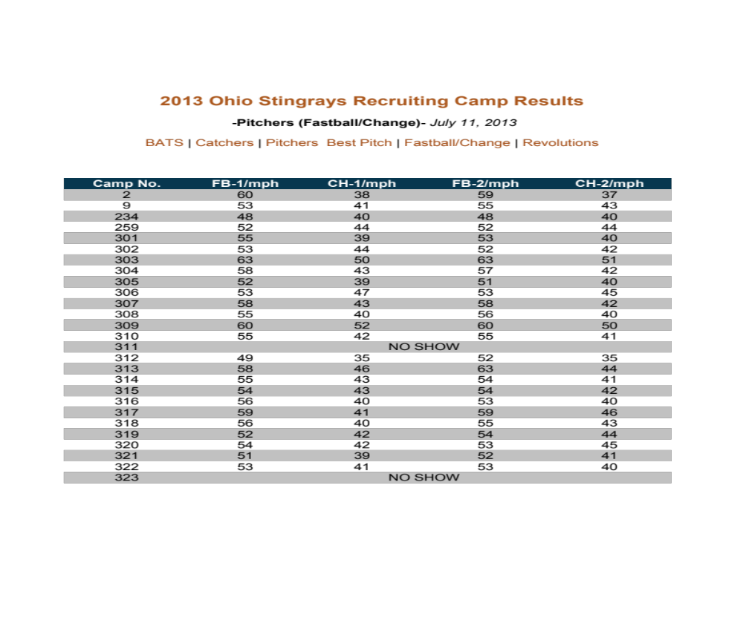

EXHIBIT 13 (CONTINUED)
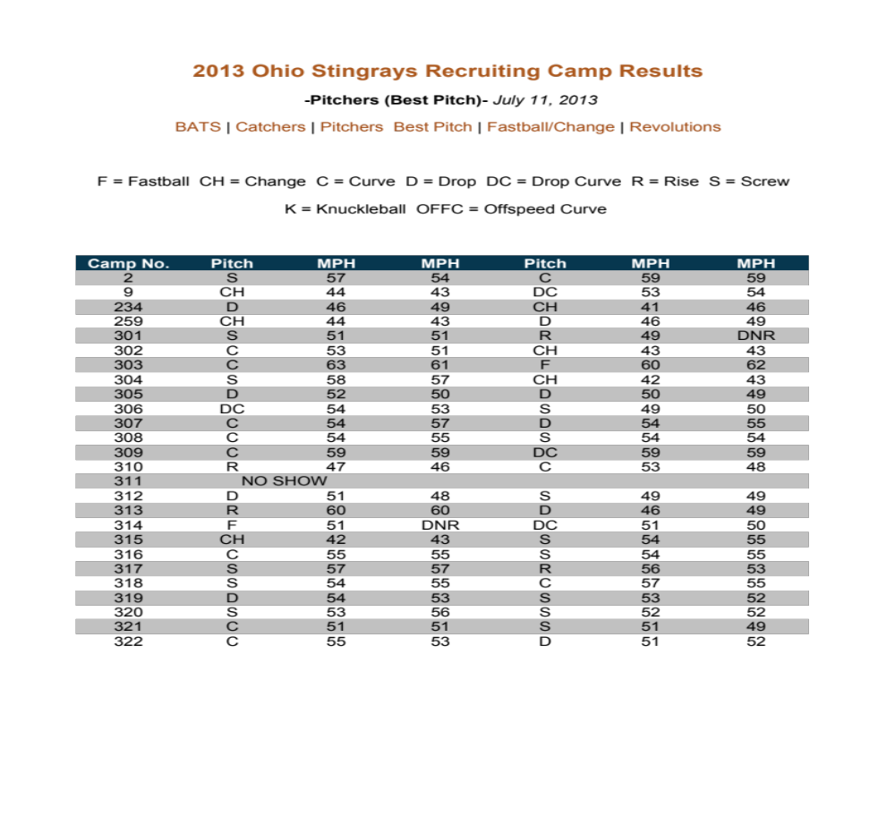

EXHIBIT 13 (CONTINUED)
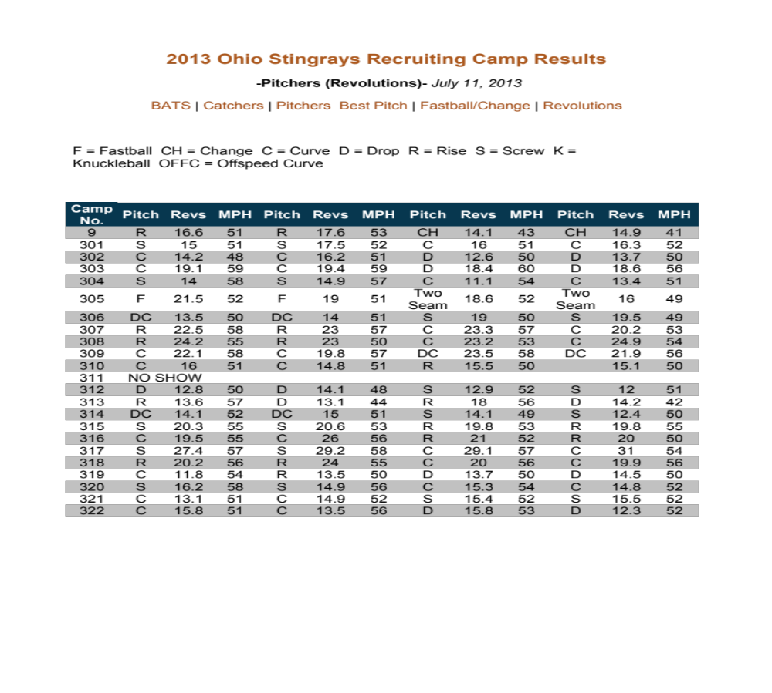

EXHIBIT 13 (CONTINUED)
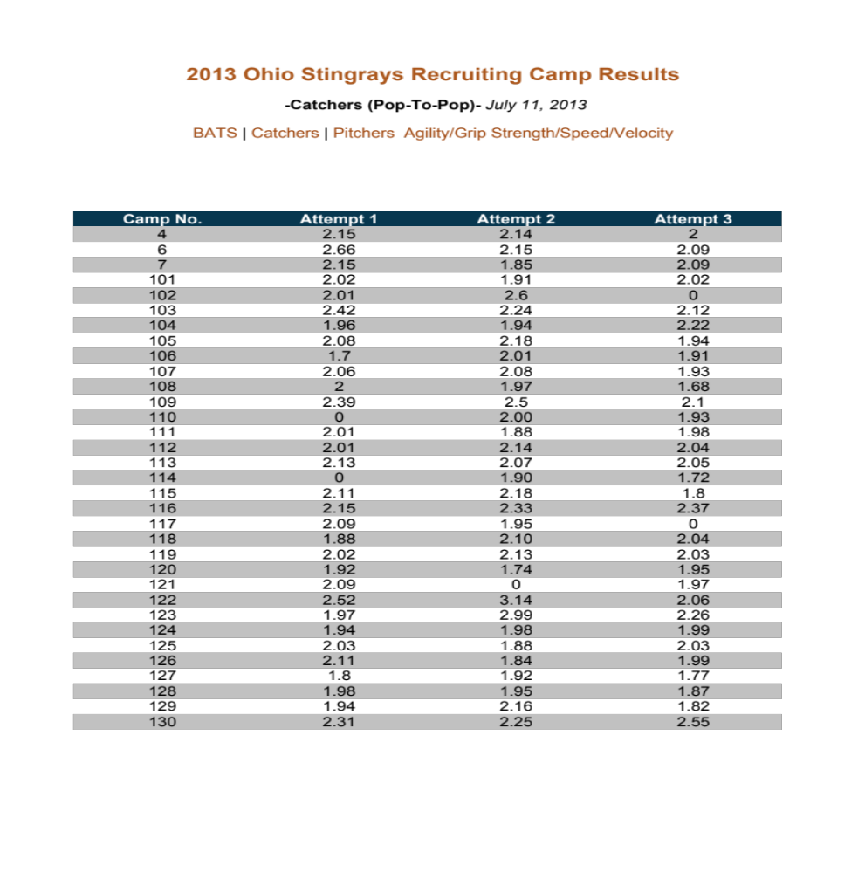

EXHIBIT 13 (CONTINUED)
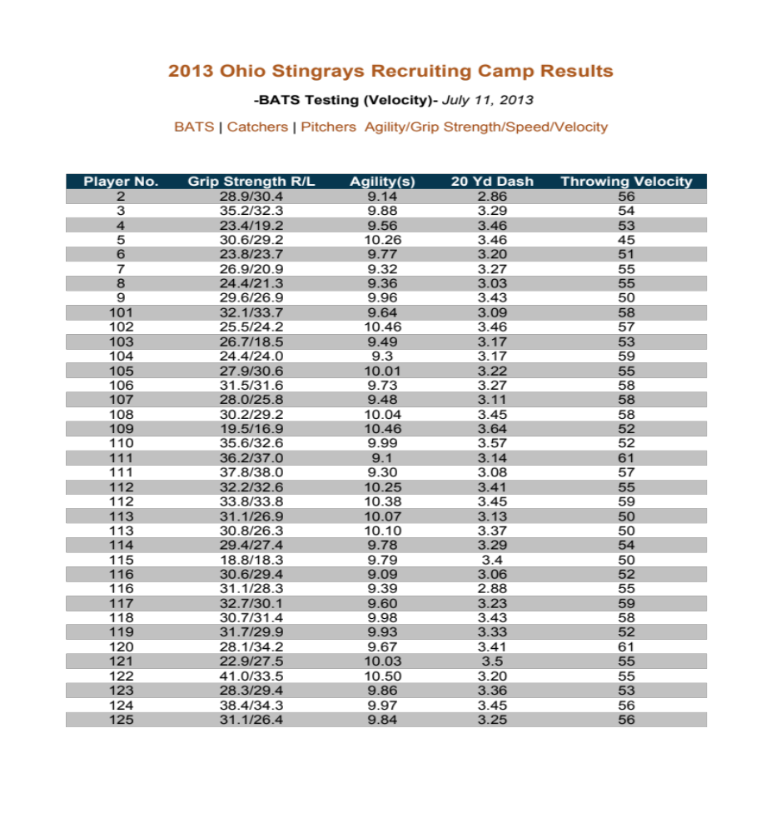

EXHIBIT 14
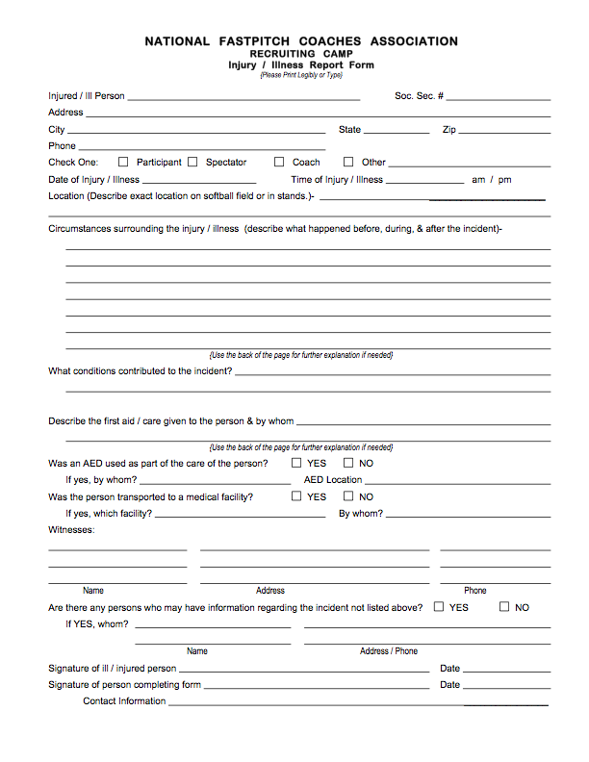

EXHIBIT 15

MEASURING
THE SOFTBALL
STUDENT-ATHLETE

MANUAL

ADVANCED TIMING

* Skills may be measured using alternate equipment*
-Please contact the NFCA regarding any questions on this-

1. Fastest Pitch Velocity PITCHERS ONLY
Mandatory Test
A. Equipment:
• 50’ of dirt, turf, grass, or gym floor
• Tape Measure
• Pitching rubber (optional)
• Home plate (optional)
• Softballs x 6 (regulation 12” size)
• Catcher (or receiving net)
• Approved radar gun properly calibrated (Pocket Radar, Jugs, Stalker)
B. Personnel:
• Set-up person
• Radar gun operator
C. Set-up:
• Measure 43’
• Place 3 balls behind pitching rubber
• Receiving net behind home plate (or a catcher)
• Radar gun behind net or catcher
D. Process:
• Pitcher selects her fastest pitch and throws it 6 times.
• If a pitch “misses” the readable area, that pitch counts as an attempt but does not count as a valid pitch and the speed for that pitch is not recorded.
• The Recorder records the speeds of the valid pitches only.
• The speed is reported for either the 3 fastest valid pitches or for all valid pitches, whichever number of pitches is less.
• The pitcher gets a maximum of 6 pitches.

Level 2 equipment options and prices:
• Pocket radar ($200)
• Jugs radar ($1,100)
• Stalker radar ($500)

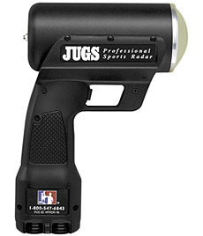
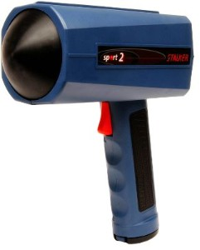
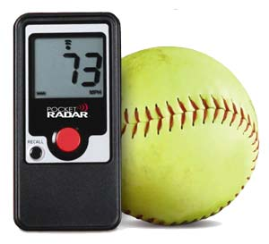

2. Change Up (Off Speed) Pitch Velocity PITCHERS ONLY
Mandatory Test
A. Equipment:
• 50’ of dirt, turf, grass, or gym floor
• Tape Measure
• Pitching rubber (optional)
• Home plate (optional)
• Softballs x 6 (regulation 12” size)
• Catcher (or receiving net)
• Approved radar gun properly calibrated
B. Personnel:
• Set-up person
• Radar gun operator
C. Set-up:
• Measure 43’
• Place 3 balls behind pitching rubber
• Receiving net behind home plate (or a catcher)
• Radar gun behind net or catcher
D. Process:
• Pitcher selects her off-speed pitch and throws it 3 times.
• If a pitch “misses” the readable area, that pitch counts as an attempt but does not count as a valid pitch and the speed for that pitch is not recorded.
• The speed is reported for either the first 3 valid pitches or for all valid pitches, whichever number of pitches is less.
• The pitcher gets a maximum of 6 pitches.

Level 2 equipment options and prices:
• Pocket radar ($200)
• Jugs radar ($1,100)
• Stalker ($500)

3. RPM PITCHERS ONLY
Mandatory Test
A. Equipment:
• 50’ of dirt, turf, grass, or gym floor
• Tape Measure
• Pitching rubber (temporary or permanent)
• Home plate (temporary or permanent)
• Catcher (or receiving net)
• RevFire softballs x 2
• RevFire properly calibrated
B. Personnel:
• Set-up person
• RevFire operator
C. Set-up:
• Measure 43’
• Place 3 balls behind pitching rubber
• Receiving net behind home plate (or a catcher)
• RevFire gun behind net or catcher
D. Process:
• Pitcher selects a spin pitch and throws that same pitch 6 times.
• If a pitch “misses” the readable area, that pitch counts as an attempt but does not count as a valid pitch and the speed and spin rate (RPM) for that pitch is not recorded.
• The Recorder records the pitch type, speed, and RPM of the valid pitches only.
• The pitch type, speed, and RPM is reported for either the valid pitches with the top 3 RPM or for all valid pitches, whichever number of pitches is less.
• The pitcher gets a maximum of 6 pitches.

Level 2 equipment options and prices:
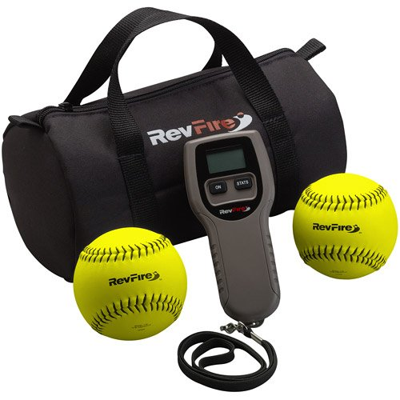
• RevFire ($350)

4. Pop Time CATCHERS ONLY
Mandatory Test
A. Equipment:
• Tape Measure
• Stop watch x 2
• Softballs
• Receiving net
• Full catcher’s gear
B. Personnel:
• Set-up person
• Stopwatch operator
• Receiver (shortstop)
C. Set-up:
• Measure 84’ 10 ¼”
• Catcher sets up behind home plate in full catcher’s gear.
• Set up pitching machine 43’ away to throw between 59-61 mph. Measure speed with a radar gun.
• Receiver is sitting on a bucket 84’ 10 ¼” from home plate. Cannot leave bucket to receive ball.
D. Process:
• Pitching machine operator puts ball into machine.
• Catcher receives and throws down to receiver on bucket.
• Timer starts stopwatch when ball hits catcher’s glove, stops when ball hits receiver’s glove.
• 6 attempts, record best 3 times. Overthrows and underthrows count as an attempt.
• 2 stopwatches: one is the official measure, the other is an unofficial measure. (Note: on any given throw, if the unofficial measure varies from the official measure by .10 seconds or more, the measure is discarded and another attempt is granted. Keeps the official recorder consistent and highlights any glaring mis-times.)

Level 2 equipment options and prices:
• Stopwatch ($10)

5. Overhand Throw Velocity ALL POSITIONS
Mandatory Test
A. Equipment:
• 70 feet of grass/turf/gym floor
• Chalk/paint/marker for throw line(s)
• Bucket of 12” softballs
• Receiving net (or receiver)
• Approved radar gun (Pocket Radar)*
B. Personnel:
• Set-up person
• Radar gun operator
C. Set-up:
• Mark throwing line
• Measure 60’ from throwing line and mark receiving line
• Place receiving net (or receiver) at the receiving line
D. Process:
• Player starts behind the throw line and shuffles (L/R/L/Throw) and throws overhand 6 times.
• If a throw “misses” the readable area, that throw counts as an attempt but does not count as a valid throw and the speed for that throw is not recorded.
• If the player steps over the throwing line prior to, during, or after release of the ball, the speed for that throw is not recorded.
• The Recorder records the speeds of the valid throws only.
• The speed is reported for either the fastest 3 valid throws or for all valid throws, whichever number of throws is less.
• The player receives a maximum of 6 throws.

Level 2 equipment options and prices:
• Pocket radar ($200)
• Jugs radar ($1,100)
• Stalker ($500)

6. Ball Exit Speed ALL HITTERS
Mandatory Test
A. Equipment:
• 50’ of dirt, turf, or gym floor
• Hitting tee
• Newer softballs, (specs as stated in rule book)
• Net to hit into (for efficiency) – not required
• Radar gun
B. Personnel:
• Set-up person
• Radar gun operator
C. Set-up:
• Set up hitting tee approximately 3’ in front of the hitting net
• Radar operator, set up behind hitter
D. Process:
• 5 attempts total, record top 3 times.
• If the player misses the ball it counts as an attempt.
• Measure speed of ball from behind the batter.
• Take the best 3 ball exit speeds.
• Calculate average ball exit of all valid hits.

Level 2 equipment options and prices:
• Pocket radar ($200)
• Tee ($25)

7. Pro Agility Shuttle ALL POSITIONS
Recommended but not Mandatory Test
A. Equipment:
• 40 feet of dirt or turf
• Cones x 4
• Timing eyes
• Charting material
• Tape measure
B. Personnel:
• Set-up person
• Timing eye operator
C. Set-up:
• Middle cone with side lateral cones 5 yards to each side
• Lateral cones staggered slightly behind center cone to avoid tripping on center cone
• Timing eye set up in center, set to stop time after second time player crosses
D. Process:
• 2 runs.
• To start, player touches center cone with glove side hand.
• Operator starts timing eye when hand leaves center cone.
• Timing eye automatically stops when player crosses the center-line for the SECOND time.
• Player touches both lateral side cones with hand. Player must face the same direction the whole time. When starting to the right, right hand touches the line, then left hand on opposite line, sprint through center-line.
• Test both directions and average.

Level 2 equipment options and prices:
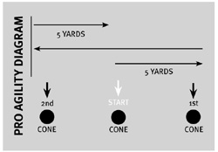
• Timing eyes ($1,100)
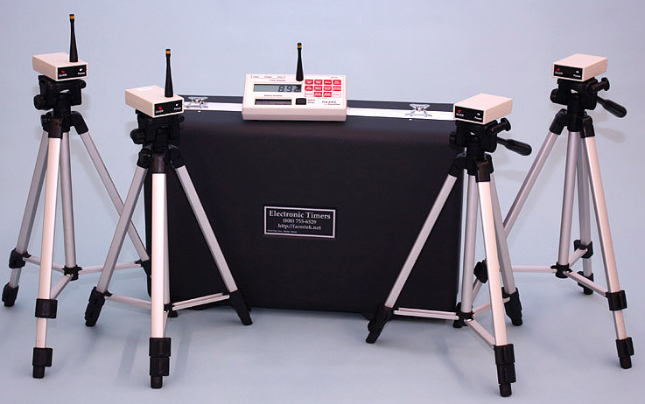
• Cones ($10)

8. 20 Yard Sprint ALL POSITIONS
Mandatory Test
A. Equipment:
• 70 feet of dirt or turf
• Cones x 4 (6” agility cones or marks at 20 yards)
• Stopwatch or radar
• Timing eyes
• Charting material
• Tape measure
B. Personnel:
• Set-up person
• Timing eyes operator
C. Set-up:
• Starting cones and finish cones, 20 yards apart
• Timing eyes at start and finish line. Set up low to ground at start line so hand doesn’t trip the start timer.
D. Process:
• 2 runs.
• Player sets up behind start line, starts when ready.
• Retest once if player slips.
• Time starts when player breaks plane of first timing eye, stops when player breaks plane of second timing eye at finish line.

Level 2 equipment options and prices:
• Timing eyes ($1,100)
• Cones ($10)

9. Vertical Jump ALL POSITIONS
Recommended but not Mandatory Test
A. Equipment:
• Small area
• Jump stick or jump mat
• Chart materials
B. Personnel:
• Observer/recorder
C. Set-up:
• Set jump stick or jump mat in an area with room for athletes to jump
D. Process:
Jump Stick:
• 3 jumps.
• Athlete stands next to jump stick and extends arm. Mark height.
• Athlete stands under jump stick, jumps as high as possible and taps jump stick at peak. Difference between reach and jump is recorded.
• The best of 3 attempts is recorded.
Jump Mat:
• 3 jumps.
• Athlete stands on the mat, loads down and swings both arms up and jumps as high as possible and lands with legs fairly straight.
• Jump mat operator records all 3 jumps.

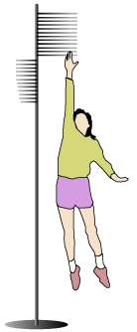
Level 2 equipment options and prices:
• Jump stick ($150 – $200)
• Jump mat ($600)

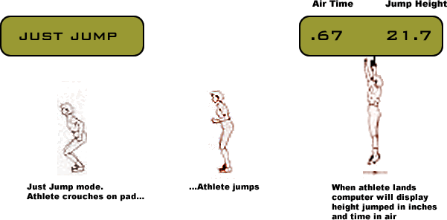

10. Grip Strength ALL POSITIONS
Recommended but not Mandatory Test
A. Equipment:
• Dynamometer
• Charting material
B. Personnel:
• Observer/recorder
C. Set-up:
• None
D. Process:
• The player holds the dynamometer in the hand to be tested, with the arm at right angles and the elbow by the side of the body. The handle of the dynamometer is adjusted if required – the base should rest on first metacarpal (heel of palm), while the handle should rest on middle of four fingers. When ready, the player squeezes the dynamometer with maximum isometric effort, which is maintained for about 5 seconds. No other body movement is allowed. The player should be strongly encouraged to give a maximum effort.
• Scoring: the best result from 3 trials for each hand is recorded, with at least 15 seconds recovery between each effort.
• Record the best effort for each hand.

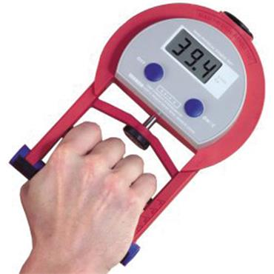
Level 2 equipment options and prices:
• Dynamometer ($280)

